

**Artworks Sharing Platform**

**Software Requirement Specification**

Project Code: FU-SPR2024-NJS1709-SR302

Document Code: FU-SPR2024-NJS1709-SR302-SRS–v1.0

**Ho Chi Minh, 28/01/2024**

**Record of change**

*A - Added M - Modified D - Deleted

| **Effective Date** | **Changed Items** | **A, M, D** | **Change Description** | **New Version** |
| --- | --- | --- | --- | --- |
|  | Use case: Sign up | Add | Add “Sign up” use case detail | 1.0 |
|  | Use case: Login | Add | Add “Register account” use case detail | 1.0 |
|  | Use case: View profile | Add | Add “View profile” use case detail | 1.0 |
|  | Use case: Edit profile | Add | Add “Edit profile” use case detail | 1.0 |
|  | Use case: Reset password | Add | Add “Reset password” use case detail | 1.0 |
|  | Use case: Remove account | Add | Add “Remove account” use case detail | 1.0 |
|  | Use case: Edit information of artworks | Add | Add “Edit information of artworks” use case detail | 1.0 |
|  | Use case: View profile | Add | Add “View profile” use case detail | 1.0 |
|  | Use case: Edit profile | Add | Add “Edit profile” use case detail | 1.0 |
|  | Use case: View artworks | Add | Add “View artworks” use case detail | 1.0 |
|  | Use case: View artwork detail | Add | Add “View artwork detail” use case detail | 1.0 |
|  | Use case: Remove artwork | Add | Add “Remove artwork” use case detail | 1.0 |
|  | Use case: Upload artwork | Add | Add “ Upload artwork” use case detail | 1.0 |
|  | Use case: View list of user accounts | Add | Add “View list of user accounts  ” use case detail | 1.0 |
|  | Use case: Remove account | Add | Add “Register account” use case detail | 1.0 |
|  | Use case: View artistic service | Add | Add “View artistic service” use case detail | 1.0 |
|  | Use case: Reset password | Add | Add “Reset password” use case detail | 1.0 |
|  | Use case: Report creator | Add | Add “Report creator” use case detail | 1.0 |
|  | Use case: View premium package | Add | Add “View premium package” use case detail | 1.0 |
|  | Use case: View reported artwork | Add | Add “View reported artwork” use case detail | 1.0 |
|  | Use case: Add to cart | Add | Add “Add to cart” use case detail | 1.0 |
|  | Use case: Update package | Add | Add “Update package” use case detail | 1.0 |
|  | Use case: Report artwork | Add | Add “Report artwork” use case detail | 1.0 |
|  | Use case: Update package | Add | Add “Update package” use case detail | 1.0 |
|  | Use case: Upgrade to creator | Add | Add “Upgrade to creator” use case detail | 1.0 |
|  | Use case: View cart | Add | Add “View cart” use case detail | 1.0 |
|  | Use case: View artist | Add | Add “View artist” use case detail | 1.0 |
|  | Use case: Search artwork | Add | Add “Search artwork” use case detail | 1.0 |

**SIGNATURE PAGE**

|  | |
| --- | --- |
| **Leader** | **Dang Cong Hung - SE171500** |
| **Group Member** | **Nguyen Tan Hung - QE170205**  **Nguyen Huu Minh Tai - SE170053**  **Pham Le Quy Anh - SE170529** |
| **Supervisor** | **Ms.Nguyen Thi Cam Huong** |

**TABLE OF CONTENTS**

**1. Introduction 6**

1.1. Purpose 6

1.2. Scope 6

1.3. Definitions, Acronyms, and Abbreviations 6

1.4. References 6

1.5. Overview 7

**2. Overall Description 8**

**3. FUNCTIONAL REQUIREMENTS 10**

3.1. Use Cases Diagram 10

3.2. Login 11

3.3. Sign Up 14

3.4. Pay by Stripe 17

3.5. View profile 19

3.6. Edit profile 21

3.7. View artworks 23

3.8. View artwork detail 25

3.9. Add to cart 27

3.10. View list of artworks 29

3.11. Remove artwork 31

3.12. Upload artwork 33

3.13. View list of user accounts 35

3.14. Remove account 37

3.15. View artistic service 39

3.16. Reset password 41

3.17. Report creator 43

3.18. Report artwork 45

3.19. View premium package 46

3.20. View Reported Artwork 48

3.21. View Reported User 49

3.22. Update package 50

3.23. View artist 52

3.24. Edit information of artworks 54

3.25. Upgrade to creator 55

3.26. View cart 57

3.27. Upgrade to creator 59

3.28. Provide drawing service 60

3.29. Search artwork 62

**4. NON-FUNCTIONAL Requirements 64**

4.1. Usability 64

4.2. Reliability 64

4.3. Performance 64

# Introduction

Creating a wonderful platform for people who are interested in art, named **H3ArT**-**Artwork Sharing Platform**. **H3ArT** is innovative online platform that promotes creativity, connects artists with enthusiasts, and facilitates artwork exploration and sale. This document defines the **H3ArT** platform’s extensive specifications and functions, which cater to the demands of artists, purchasers, and art lovers.

## Screen flow

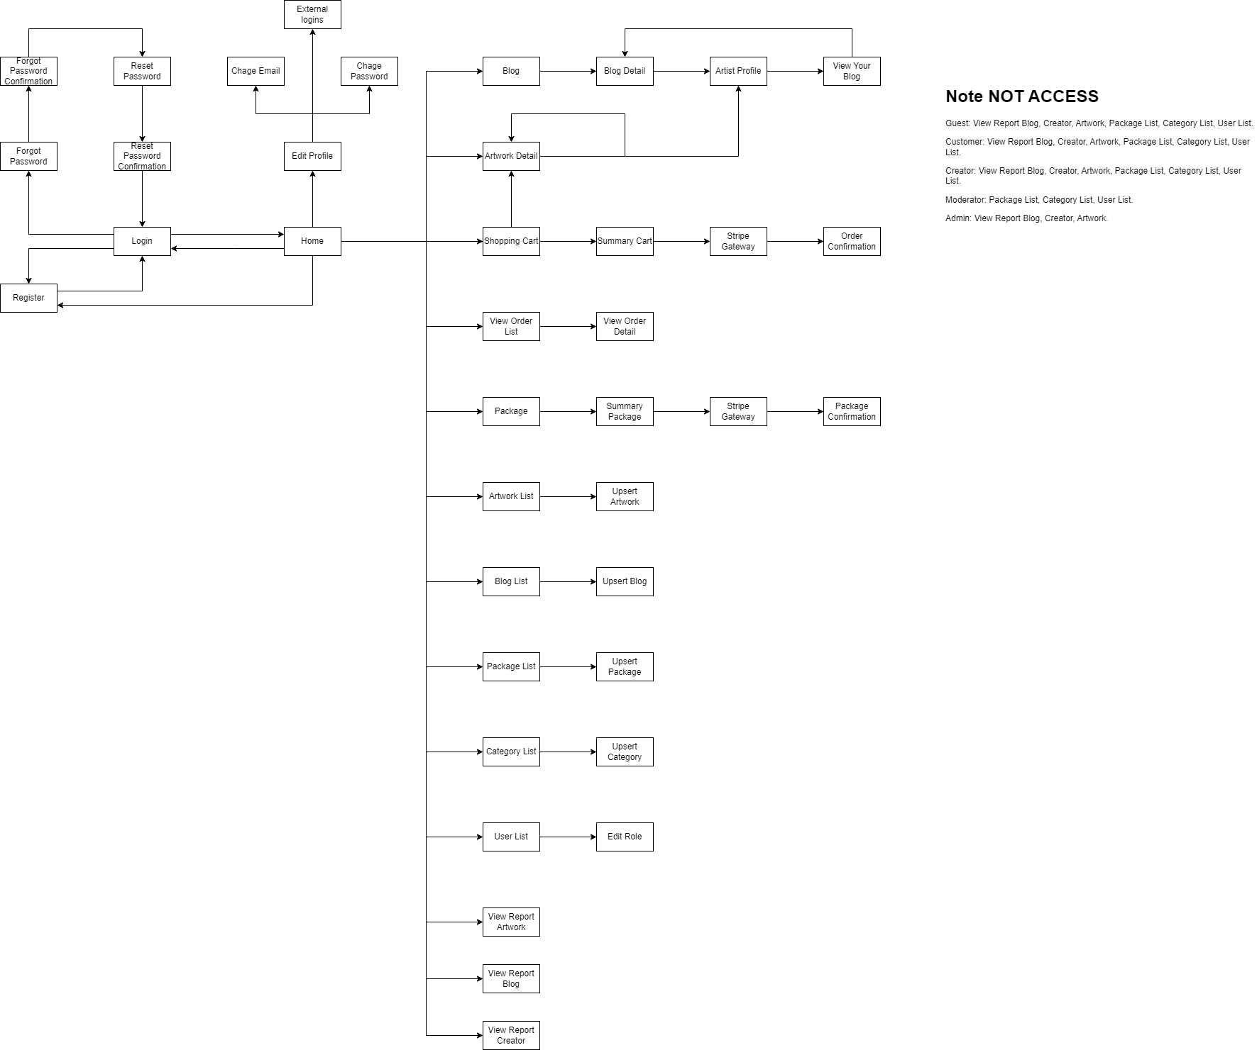

## Entity-Relationship Model

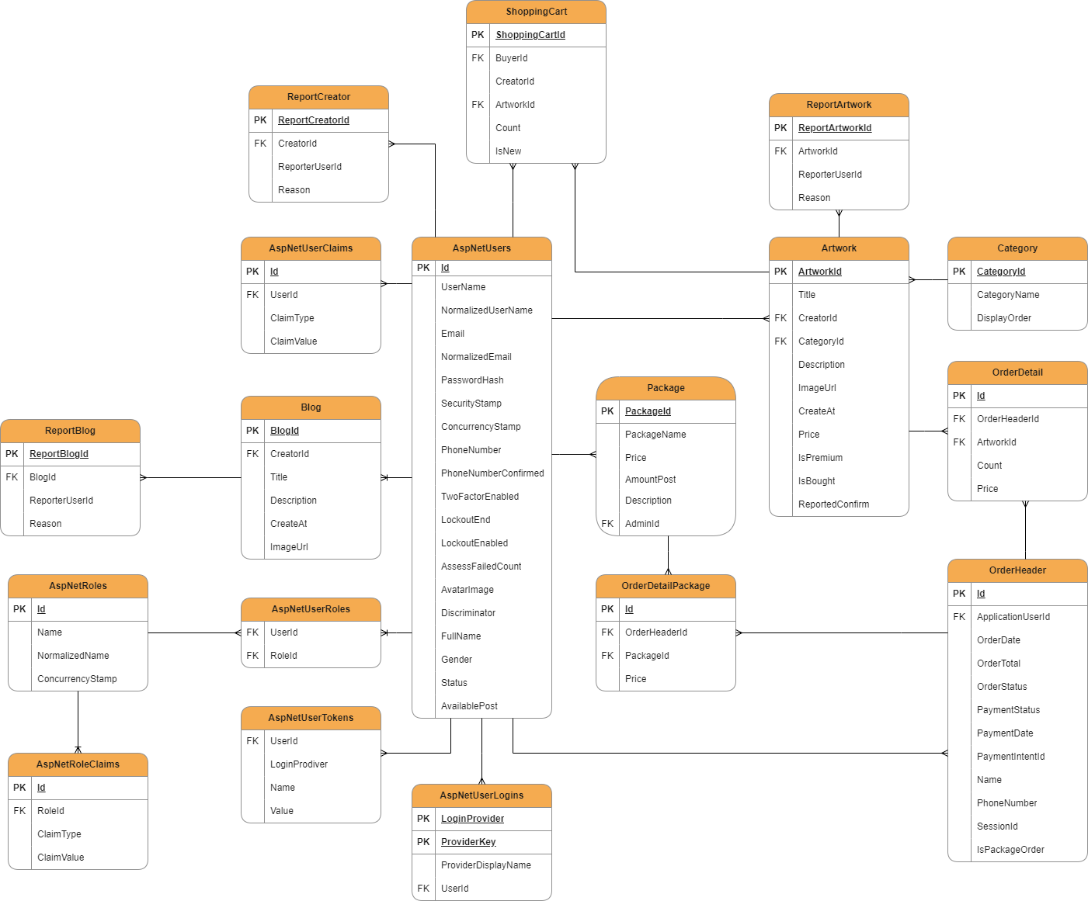

## Purpose

This document serves as the Software Requirements Specification (SRS) for the **Artwork Sharing Platform**. Its primary purpose is to provide a comprehensive guide outlining the scope, functional and non-functional requirements, constraints, and interfaces of the platform. It describes the entire logic sub-component, including both functional and non-functional software requirements, while also detailing the design of the system's interfaces in depth.

## Scope

**H3ArT** is an innovative platform designed to support customers seeking artwork at reasonable prices and creators looking to share and sell their creations. The platform facilitates connections between customers and creators, manages orders, and handles payments efficiently.

Specifically, **H3ArT** allows customers and creators to browse diverse blogs and artworks through various categories or keywords. Users can report any content that violates rights or guidelines. Once they find desired items, they can add them to their carts, proceed to checkout, place orders, and make payments. If necessary, customers can cancel unpaid orders.

Creators have the ability to upload art-related blogs and, by choosing from different package options, they can also upload their artwork for sale, possibly paying a fee for certain uploading services.

The platform includes moderation features, enabling moderators to review reported blogs, creators, and artworks, and take appropriate actions. Administrators have comprehensive control over user management, including creating, removing user accounts or updating user’s role, as well as overseeing all artworks, blogs and creators on the platform.

We have developed a comprehensive use-case model outlining the interactions between users and the system, along with detailed functional and non-functional requirements. Additionally, we have created an Entity-Relationship Diagram (ERD) and a relational schema to provide a clear understanding of the platform's data structure and relationships.

## Definitions, Acronyms, and Abbreviations

| **Acronym** | **Definition** | **Abbreviations** |
| --- | --- | --- |
| Guest | A person using the web application without signing in. |  |
| Customer | A person who has signed in as a customer, with the purpose of reading blogs, viewing, and purchasing artworks. |  |
| Creator | A person who has signed in as a creator, with the purpose of uploading artworks for sale. They can also read blogs and view/buy artworks. |  |
| Moderator | A person who has signed in as a moderator, with the purpose of taking action on reported blogs, artworks, or creators. |  |
| Admin | A person who has signed in as an admin, with the purpose of managing users, artworks, and blogs. They can also create a new user account. |  |

## References

*1.4.1. Website:*

* https://www.ibm.com/docs/en/rational-soft-arch/9.6.1?topic=diagrams-use-case
* www.wikipedia.org

*1.4.2 Books:*

* Software Engineering Seventh Edition Ian Sommerville.
* Software Engineering Ed.2 by Jalota & Pankaj.

## Overview

The Software Requirements Specification (SRS) serves as a guide for software development, outlining requirements and objectives. It covers the overall working and value of the SRS, including development costs and time estimates. The document summarizes the art-sharing platform’s purpose, highlights its main objectives, and emphasizes user objectives and characteristics. Functional requirements specify system behavior, input-output relationships, and valid data ranges, while interface requirements describe communication with other components and users.

# Overall Description

**2.1 Guest Requirements**

* Guests, individuals who have not yet authenticated into the platform, have limited access to certain functions:
* Sign Up: Guests can register for an account on the platform.
* Log In: Guests can log in to their existing accounts.
* View Artwork: Guests can browse and explore artwork created by Creators.
* View Artwork Detail: Customers can view an artwork in detail.
* Search: Guests can search for artwork based on genre or keywords.

**2.2. Customer Requirements**

* *Customers, users authenticated with the "Customer" role, have access to a variety of functionalities tailored to enhance their experience on the platform:*
* *View Artwork: Customers can browse and explore artwork created by Creators.*
* *Search: Customers can search for artwork based on genre or keywords.*
* *View Artwork Detail: Customers can inspect artwork in detail, exploring its intricacies.*
* *Purchase Premium Artwork: Customers can buy premium artwork available on the platform.*
* *Interact: Customers can engage with artwork by leaving comments and liking them, fostering community interaction.*
* *Propose Artistic Service: Customers can request specific artistic services from Creators, facilitating collaboration.*
* *Upgrade to Creator: Customers have the option to pay for upgrading their roles to Creator, enabling them to upload their artworks and participate more actively in the platform.*
* *Reset Password: Customers can reset their password to regain access to their account in case of forgetting or compromising it.*
* *View / Edit Profiles: Customers can view and edit their profiles, enabling them to manage their personal information and preferences efficiently.*

**2.3 Creator Requirements**

* Creators, users logged in with the "Creator" role, have specialized functionalities aimed at facilitating their role as artists and contributors to the platform:
* Publish Artwork: Creators can upload and publish their artwork for others to view.
* Sell Artwork: Creators can offer their artwork for sale on the platform.
* Offer Artistic Services: Creators can provide artistic services upon request from customers.
* *Reset Password: Creators can reset their password to regain access to their account in case of forgetting or compromising it.*
* *View / Edit Profiles: Creators can view and edit their profiles, enabling them to manage their personal information and preferences efficiently.*
* *Purchase Premium Artwork: Creators can buy premium artwork available on the platform.*

**2.4 Admin Requirements**

* Administrators, users with administrative privileges, have access to functionalities necessary for managing and overseeing the platform:
* *View Premium Package: Administrators can create, modify, and remove premium packages, adjusting their features as needed.*
* *View List of User Accounts: Administrators can oversee user accounts and efficiently remove them as necessary.*

**2.5 Moderator Requirements**

* Moderators, designated users responsible for maintaining a positive and safe environment on the platform, have specific duties and permissions:
* Content Moderation: Moderators oversee content uploaded by Creators and monitor interactions between users.
* Address Complaints: Moderators handle complaints and reports submitted by users regarding content or behavior on the platform.

# FUNCTIONAL REQUIREMENTS

The H3ArT – Artwork Sharing Platform will have 4 roles:

1. Admin.

2. Customer.

3. Creator.

4. Moderator.

Following features/modules will be available to these 4 different roles

| **Admin** | **Customer** | **Creator** | **Moderator** |
| --- | --- | --- | --- |
| Login & Logout | Login & Logout | Login & Logout | Login & Logout |
| New Account |  |  |  |
| View List Account | View User Profile | View User Profile |  |
| Update Role | Edit User Profile | Edit User Profile |  |
| Ban Account | Change Password | Change Password | Ban Account |
| Unban Account | Reset Password | Reset Password | Unban Account |
| View List Package | View Cart | View Cart |  |
| Create Package | Remove Item | Remove Item |  |
| Delete Package | Register Account | Resigter Account |  |
| Update Package | Place Order | Place Order |  |
|  | Pay By Stripe | Pay By Stripe |  |
|  | View Artworks | View Artworks | View Artworks |
|  | View Artwork Detail | View Artwork Detail | View Artwork Detail |
|  | Add To Cart | Add To Cart |  |
|  | Report Artwork | Report Artwork |  |
|  | Search Artworks | Search Artworks | Search Artworks |
|  | View Blogs | View Blogs | View Blogs |
|  | View Blog Detail | View Blog Detail | View Blog Detail |
|  | Report Blog | Report Blog |  |
|  | View Creator Profile | View Creator Profile | View Creator Profile |
|  | Report Creator | Report Creator |  |
| View List Order | View List Order | View List Order |  |
| View Order Detail | View Order Detail | View Order Detail |  |
|  |  | View Package |  |
| Process Order |  |  |  |
| Complete Order |  |  |  |
| Cancel Order | Cancel Order | Cancel Order |  |
| View List Blog |  | View List Blog |  |
|  |  | Create Blog |  |
| Remove Blog |  | Remove Blog | Remove Blog |
|  |  | Edit Blog |  |
| View List Artwork |  | View List Artwork |  |
| Remove Artwork |  | Remove Artwork |  |
|  |  | Upload Artwork |  |
|  |  | Edit Artwork |  |
|  |  |  | View List Reported Artwork |
|  |  |  | Hide Artwork |
|  |  |  | Unhide Artwork |
|  |  |  | View List Reported Blog |
|  |  |  |  |
|  |  |  | View List Reported Creator |

Description of the modules:

| **Module Name** | **Applicable Roles** | **Description** |
| --- | --- | --- |
| New Account | Admin | **Admin:** An admin can add a new customer/ creator/ moderator/ admin. |
| Register Account | Creator Customer | **Customer:** A customer can register a new account.  **Creator:** A creator can register a new account. |
| View List Account | Admin | **Admin:** An admin can view a list of all accounts. |
| Update Role | Admin | **Admin:** An admin can update the role of an account(s). |
| Ban Account | Admin  Moderator | **Admin:** An admin can ban all accounts.  **Moderator:** A moderator can ban creator/customer accounts. |
| Unban Account | Admin Moderator | **Admin:** An admin can unban all accounts.  **Moderator:** A moderator can unban creator/customer accounts. |
| View List Package | Admin | **Admin:** An admin can view a list of packages. |
| Create Package | Admin | **Admin:** An admin can create a package. |
| Delete Package | Admin | **Admin:** An admin can delete a package. |
| Update Package | Admin | **Admin:** An admin can update a package. |
| View List Order | Admin  Customer  Creator | **Admin:** An admin can view a list of all orders.  **Customer:** An admin can view a list of customer’s orders.  **Creator:** An admin can view a list of creator’s orders. |
| View Order Detail | Admin  Customer  Creator | **Admin:** An admin can view the details of order.  **Customer:** A customer can view the details of order.  **Creator:** A creator can view the details of order. |
| Process Order | Admin | **Admin:** An admin can mark order status as “Process”. |
| Complete Order | Admin | **Admin:** An admin can mark order status as “Complete”. |
| Cancel Order | Admin  Customer  Creator | **Admin:** An admin can cancel an order(s).  **Customer:** A customer can cancel a customer's order.  **Creator:** A creator can cancel a creator’s order. |
| View List Blog | Admin  Creator | **Admin:** An admin can view the list of all blogs.  **Creator:** A creator can view the list of all blogs(except hidden reports). |
| Remove Blog | Admin  Creator  Moderator | **Admin:** An admin can remove a blog.  **Moderator:** A moderator can remove a blog.  **Creator:** A creator can remove a creator's blog. |
| View User Profile | Customer  Creator | **Creator:** A creator can view a user profile.  **Customer:** A customer can view a user profile. |
| Edit User Profile | Customer  Creator | **Creator:** A creator can edit the creator’s profile.  **Customer:** A customer can edit the customer’s user profile. |
| Change Password | Customer  Creator | **Creator:** A creator can change the creator's password.  **Customer:** A customer can change the customer’s password. |
| Reset Password | Customer  Creator | **Creator:** A creator can reset the creator's password.  **Customer:** A customer can reset the customer’s password. |
| View Cart | Customer  Creator | **Creator:** A creator can view the creator's cart.  **Customer:** A customer can view the customer’s cart. |
| Remove Item | Customer  Creator | **Creator:** A creator can remove item(s) in the creator's cart.  **Customer:** A customer can remove items(s) in the customer’s cart. |
| Check Out (bo) | Customer  Creator | **Creator:** A creator can check out.  **Customer:** A customer can check out. |
| Place Order | Customer  Creator | **Creator:** A creator can place orders.  **Customer:** A customer can place orders. |
| Pay By Stripe | Customer  Creator | **Creator:** A creator can use Stripe to do the payment.  **Customer:** A customer can use Stripe to do the payment. |
| View Artworks | Customer  Creator  Moderator | **Customer:** A customer can view artworks.  **Moderator:** A moderator can view artworks.  **Creator:** A creator can view artworks. |
| View Artwork Detail | Customer  Creator  Moderator | **Customer:** A customer can view the details of artworks.  **Moderator:** A moderator can view the details of artworks.  **Creator:** A creator can view the details of artworks. |
| Add To Cart | Customer  Creator | **Creator:** A creator can add artwork to the creator's cart.  **Customer:** A customer can add artwork to the customer’s cart. |
| Report Artwork | Customer  Creator  Moderator | **Customer:** A customer can report artworks.  **Moderator:** A moderator can report artworks.  **Creator:** A creator can report artworks. |
| Search Artworks | Customer  Creator  Moderator | **Customer:** A customer can search artworks.  **Moderator:** A moderator can search artworks.  **Creator:** A creator can search artworks. |
| View Blogs | Customer  Creator  Moderator | **Customer:** A customer can view blogs.  **Moderator:** A moderator can view blogs.  **Creator:** A creator can view blogs. |
| View Blog Detail | Customer  Creator  Moderator | **Customer:** A customer can view the details of the blog.  **Moderator:** A moderator can view the details of the blog.  **Creator:** A creator can view the details of the blog. |
| Report Blog | Customer  Creator | **Customer:** A customer can report blogs.  **Creator:** A creator can report blogs. |
| View Creator Profile | Customer  Creator  Moderator | **Customer:** A customer can view the creator profile.  **Moderator:** A moderator can view the creator profile.  **Creator:** A creator can view the creator profile. |
| Report Creator | Customer  Creator | **Customer:** A customer can report the creator.  **Creator:** A creator can report a creator. |
| View List Order | Customer  Creator | **Customer:** A customer can view a list of customer’s order.  **Creator:** A creator can view a list of creator’s order. |
| View Order Detail | Customer  Creator | **Customer:** A customer can view a list of customer’s order details.  **Creator:** A creator can view a list of creator’s order details. |
| View Package | Creator | **Creator:** A creator can view a package. |
| Create Blog | Creator | **Creator:** A creator can create a blog. |
| Edit Blog | Creator | **Creator:** A creator can edit a blog. |
| View List Reported Artwork | Moderator | **Moderator:** A moderator can view the list of reported artworks. |
| Hide Artwork | Moderator | **Moderator:** A moderator can hide artwork. |
| Unhide Artwork | Moderator | **Moderator:** A moderator can unhide artwork. |
| View List Reported Blog | Moderator | **Moderator:** A moderator can view the list of reported blogs. |
| View List Reported User | Moderator | **Moderator:** A moderator can view the list of reported users. |

## 1.1. External Interface Requirements

**2.1.1 User Interfaces**

Utilization of various user interfaces may include:

* Stripe: Payment processing interface for secure transactions.
* Facebook: Integration for social media authentication.
* Google: Integration for authentication.
* Disqus: Integration of commenting system on blogs or artworks.
* Datatables: Integration for enhanced data presentation and manipulation.
* Toastr: Integration for display notifications or alerts to users.

**2.1.2 Hardware Interfaces**

None

**2.1.3 Software Interfaces**

None

**2.1.2 Communications Interfaces**

None

## 1.2. Technical Requirements (TRD)

**New Account**

**T1** Full Name – Full Name is required.

**T2** Full Name – Full Name cannot contain numbers.

**T3** Email – Email is required.

**T4** Email – Email format must be valid.

**T5** Password – Password is quired.

**T6** Password – Password must be at least 6 and at max 100 characters long.

**T7** Password – Password must have at least one non alphanumeric character.

**T8** Password - Password must have at least one lowercase character.

**T9** Password - Password must have at least one upper character.

**T10** Confirm Password - Confirm Password and Password must be the same.

**Edit User Profile:**

**T11** Phone Number – Phone Number must start with the digit 0 and have exactly 10 digits.

**T12** Full Name – Full Name is required.

**T13** Full Name – Full Name cannot contain numbers.

**T14** Avatar Image – Avatar Image must be a jpg file.

**Reset Password**

**T15** Password – Password is quired.

**T16** Password – Password must be at least 6 and at max 100 characters long.

**T17** Password – Password must have at least one non alphanumeric character.

**T18** Password - Password must have at least one lowercase character.

**T19** Password - Password must have at least one upper character.

**T20** Confirm Password - Confirm Password and Password must be the same.

**Change Password**

**T21** Password – Password is quired.

**T22** Password – Password must be at least 6 and at max 100 characters long.

**T23** Password – Password must have at least one non alphanumeric character.

**T24** Password - Password must have at least one lowercase character.

**T25** Password - Password must have at least one upper character.

**T26** Confirm Password - Confirm Password and Password must be the same.

**Login:**

**T27** Email - Email is required.

**T28** Email - Email must be valid

**T29** Password - Password is required.

**Register Account**

**T30** Full Name - Full Name is required.

**T31** Full Name - Full Name cannot contains number.

**T32** Full Name - Full Name is required.

**T33** Email - Email is required.

**T34** Email - Email must be valid

**T35** Password – Password is quired.

**T36** Password – Password must be at least 6 and at max 100 characters long.

**T37** Password – Password must have at least one non alphanumeric character.

**T38** Password - Password must have at least one lowercase character.

**T39** Password - Password must have at least one upper character.

**T40** Confirm Password - Confirm Password and Password must be the same.

**Create Package**

**T41** Package Name – Package Name is required.

**T42** Description – Description is required.

**T43** Price – Price must be greater than 0.

**T44** Price – Price must be a number.

**Update Package**

**T45** Package Name – Package Name is required.

**T46** Description – Description is required.

**T47** Price – Price must greater than 0.

**T48** Price – Price must be a number.

**Place Order**

**T49** Name – Name is required.

**T50** Name – Name cannot contain numbers.

**T51** Phone Number – Phone Number is required.

**T52** Phone Number – The phone Number must start with the digit 0 and have exactly 10 digits.

**Upload Artwork**

**T53** Title - Title is required.

TR_UA53_Title_Title is required

**T54** Title - Title can only contain letters and numbers, and must contain at least one letter.

**T55** Description - Description is required.

**T56** Description - Description must be at least 70 characters.

**T57** Price - Price is required.

**T58** Price - Price must be a valid number

**T59** Price - Price must be greater than 0.

**T60** Image - Image is required.

**T61** Image - Image must be a jpg file.

**Edit Artwork**

**T62** Title - Title is required.

**T63** Title - Title can only contain letters and numbers, and must contain at least one letter.

**T64** Description - Description is required.

**T65** Description - Description must be at least 70 characters.

**T66** Price - Price is required.

**T67** Price - Price must be a valid number

**T68** Price - Price must be greater than 0.

**T69** Image - Image must be a jpg file.

**Create Blog**

**T70** Title - Title is required.

**T71** Description - Description is required.

**T72** Description - Description must at least contain 100 characters.

**T73** Image - Image is required.

**T74** Image - Image must be a jpg file.

**Edit Blog**

**T75** Title - Title is required.

**T76** Description - Description is required.

**T77** Description - Description must at least contain 100 characters.

**T78** Image - Image is required.

**T79** Image - Image must be a jpg file.

**Change password**

## 1.3. Functional validations (BRD)

**New Account:**

Admin:

**F1** Admin can add a new account.

**F2** If the full name is null, show an error message.

**F3** If the full name contains number, show an error message.

**F4** If the email is null, show an error message.

**F5** If the email is invalid, show an error message.

**F6** If the password is null, show an error message.

**F7** If the password less than 6 or more than 100 characters, show an error message.

**F8** If the password does not have any non alphanumeric characters, show an error message.

**F9** If the password does not have any lowercase character, show an error message.

**F10** If the password does not have any upper character, show an error message.

**F11** If the confirmed password is not identical to the password, show an error message.

**View List Account:**

Admin:

**F12** Admin can view the list of user accounts.

**Update Role**

Admin:

**F13** Admin can update user’s role.

**F14** Admin cannot update his role.

**View User Profile**

Creator:

**F15** Creator can view his profile by clicking on “Hello”.

Customer:

**F16** Customer can view his profile by clicking on “Hello”.

**Edit User Profile**

Customer:

**F17** Customer can edit his profile if all inputs are valid.

**F17.1** Customer can not edit his profile if once or all inputs are not valid.

**F18** If the phone number does not start with the digit 0 and has exactly 10 digits, show an error.

**F19** If the full name is null, show an error message.

**F20** If the full name contains the number, show an error message.

**F21** If the avatar image is not a jpg file, show an error message.

Creator:

**F22** Creator can edit his profile if all inputs are valid.

**F22.1** Creator can not edit his profile if once or all inputs are not valid.

**F23** If the phone number does not start with the digit 0 and have exactly 10 digit, show an error.

**F24** If the full name is null, show an error message.

**F25** If the full name contains number, show an error message.

**F26** If the avatar image is not a jpg file, show an error message.

**Ban Account**

Admin:

**F27** Admin can ban user accounts on the Manage User Page.

**F28** Admin cannot ban his own account.

Moderator:

**F29** Moderator can ban creator accounts on the Report Account List.

**Unban Account**

Admin:

**F30** Admin can unban a user account on the Manage User Page.

Moderator:

**F31** Moderator can unban creator accounts on the Report Account List.

**Change password:**

Customer:

**F32** Customer must verify to change password.

**F33** If the old password is invalid, the system shows an error.

**F34** If the password is null, show an error message.

**F35** If the password is less than 6 or more than 100 characters, show an error message.

**F36** If the password does not have any non-alphanumeric characters, show an error message.

**F37** If the password does not have any lowercase characters, show an error message.

**F38** If the password does not have any upper character, show an error message.

**F39** If the confirmation password is not the same as the new password, the system will report an error.

**F40** If the new password is valid, and the confirmation password is not the same as the new password, the customer can change the password.

Creator:

**F41** Creator must verify to change the password.

**F42** If the password is null, show an error message.

**F43** If the password is less than 6 or more than 100 characters, show an error message.

**F44** If the password does not have any non-alphanumeric characters, show an error message.

**F45** If the password does not have any lowercase characters, show an error message.

**F46** If the password does not have any upper character, show an error message.

**F47** If the confirmation password is not the same as the new password, the system will show an error.

**F48** If the new password is valid, and the confirmation password is not the same as the new password, the creator can change the password.

**Reset Password**

Customer/Creator:

**F49** If the email is invalid, the system shows an error.

**F50** If the email does not exist, the system shows an error.

**F52** Send mail with callbackUrl if email is valid.

**F53** The callbackUr is valid.

**F60** If the password is null, show an error message.

**F61** If the password is less than 6 or more than 100 characters, show an error message.

**F62** If the password does not have any non-alphanumeric characters, show an error message.

**F63** If the password does not have any lowercase characters, show an error message.

**F64** If the password does not have any upper character, show an error message.

**F65** If the confirmation password is not the same as the new password, the system will show an error.

**F66** If the email is valid and the confirmation password is the same as the new valid password, the customer can reset the password.

**View List Package**

Admin:

**F67** Admin can view the list of packages.

**View Cart**

Customer:

**F68** Customer can view the list of artwork in carts of himself

Creator:

**F69** Creator can view the list of artwork in carts of himself

**Create package**

Admin:

**F70** If the Price of the package is less than 0, the system will show the error.

**F71** If the Amount Post of the package is less than 0, the system will show the error.

**F72** If the Description of the package is blank, the system will show the error.

**F73** If the Package Name is blank, the system will show the error.

**Remove item**

Creator:

**F74** Creators successfully removed the items.

Customer:

**F75** Customer successfully removed the items.

**Delete package**

Admin:

**F76** Admin should be able to delete the package.

**Update package**

Admin:

**F77** If the new Price of the package is less than 0, the system will show the error.

**F78** If the new Amount Post of the package is less than 0, the system will show the error.

**F79** If the new Description of the package is blank, the system will show the error.

**F80** If the new Package Name is blank, the system will show the error.

**F81** If the new Package Name, Price, Amount Post, and Description are valid, the admin can update a new package.

**Place Order**

Customer:

**F82** If the Name of the customer is blank, the system will show the error.

**F82.1** If the Name of the customer contains the number, the system will show the error.

**F83** If the phone number of the customer is blank, the system will show the error.

**F84** If the phone number is not enough 10 digits, the system will show the error.

**F85** If the phone number does not begin with “0”, the system will show the error.

**F86** If the name and phone number are valid, the customer will place the order successfully.

Creator:

**F87** If the Name of the customer is blank, the system will show the error.

**F87.1** If the Name of the customer contains the number, the system will show the error.

**F88** If the phone number of the customer is blank, the system will show the error.

**F89** If the phone number is not enough 10 digits, the system will show the error.

**F90** If the phone number does not begin with “0”, the system will show the error.

**F91** If the name and phone number are valid, the creator will place the order successfully.

**Pay by Stripe**

Customer:

**F92** If the email of the customer is blank, the system will show the error.

**F93** If the email of the customer is not valid, the system will show the error.

**F94** If the Card information of the customer is blank, the system will show the error.

**F95** If the Card information of the customer is not valid, the system will show the error.

**F95.1** If the Cardholder name of the customer is blank, the system will show the error.

**F96** If the Email, Card information, and Cardholder Name are valid, the customer will pay by Stripe successfully.

Creator:

**F97** If the email of the creator is blank, the system will show the error.

**F98** If the email of the creator is not valid, the system will show the error.

**F99** If the Card information of the creator is blank, the system will show the error.

**F100** If the Card information of the creator is not valid, the system will show the error.

**F101** If the Cardholder name of the creator is blank, the system will show the error.

**F102** If the Email, Card information, and Cardholder Name are valid, the creator will pay by Stripe successfully.

**View artwork**

Customer:

**F103** If the artwork is bought, the customer cannot see it on the home page.

**F104** The customer should view the artwork is not bought successfully.

**F105** If the artwork has been hidden by the moderator since reported, the customer cannot see it on the home page.

Creator:

**F105.1** If the artwork is bought, the creator cannot see it on the home page.

**F106** The creator should view the artwork that is not bought successfully.

**F107** If the artwork has been hidden by the moderator since reported, the creator cannot see it on the home page.

Moderator:

**F108** If the artwork is bought, the moderator cannot see it on the home page.

**F109** The moderator should view the artwork is not bought successfully.

**F110** If the artwork has been hidden by the moderator, the moderator cannot see it on the home page.

**View artwork detail**

Customer:

**F112** The customer can view the artwork details of an artwork

Creator:

**F115** The creator can view the artwork detail of an artwork

Moderator:

**F118** The moderator can view the artwork detail of an artwork

**Add to Cart:**

Customer:

**F120** Customer successfully adds an artwork to the cart, the artwork must be in the cart.

Creator:

**F121** Creator succesfully add an artwork to cart, artwork must be in the cart.

**Report Artwork**

Customer:

**F122** Customer successfully report an artwork, artwork must be added to ReportArtwork table.

Creator:

**F123** Creator successfully report an artwork, artwork must be added to ReportArtwork table.

**F124** Creator cannot report his artwork.

**Search Artworks:**

Customer:

**F125** Customer successfully search artworks by keywords.

Creator:

**F126** Creator successfully search artworks by keywords.

Moderator:

**F127** Moderator successfully search artworks by keywords.

**View Blogs:**

Customer:

**F128** Customer successfully view all blogs on Blog Page.

Creator:

**F129** Creator successfully view all blogs on Blog Page.

Moderator:

**F130** Moderator successfully view all blogs on Blog Page.

**View Blog Detail:**

Customer:

**F131** Customer successfully view a blog in detail on Blog Page.

Creator:

**F132** Creator successfully view a blog in detail on Blog Page.

Moderator:

**F133** Moderator successfully view a blog in detail on Blog Page

**Report Blog**

Customer:

**F134** Customer successfully report an blog, blog must be added to ReportBlog table.

Creator:

**F135** Creator successfully report an artwork, artwork must be added to ReportArtwork table.

**F136** Creator cannot report his blog.

**View Creator Profile**

Customer:

**F137** Customer successfully view creator profile on Creator Profile Page.

Creator:

**F138** Creator successfully view different creator profile on Creator Profile Page.

Moderator:

**F139** Moderator successfully view creator profile on Creator Profile Page.

**Report Creator**

Customer:

**F140** Customer successfully report a creator, reported creator must be added to ReportCreator table.

Creator:

**F141** Creator successfully report a different creator, reported creator must be added to ReportCreator table.

**F142** Creator cannot report himself.

**View List Order**

Admin:

**F143** Admin successfully view all orders.

Customer:

**F144** Customer successfully view his own orders.

Creator:

**F145** Creator successfully view his own orders.

**View Order Detail**

Admin:

**F146** Admin successfully view an order in detail.

Customer:

**F147** Customer successfully view an order in detail.

Creator:

**F148** Creator successfully view an order in detail.

**View Pakage:**

Ceartor:

**F149** Creator successfully view packages on the Package Page.

**Process Order:**

Admin:

**F150** Admin processes an order, the order status changes to “Processing”.

**Complete Order:**

Admin:

**F151** If an order is completed, the order status changes to “Completed”.

**Cancel Order:**

Admin:

**F152** If the order status is approved, cancel order will refund money, change the status to “Cancel”.

**F153** If the order status is pending, change the status to “Cancel”.

Customer:

**F154** If the order status is pending, change the status to “Cancel”.

Creator:

**F155** If the order status is pending, change the status to “Cancel”.

**View List Blog:**

Admin:

**F156** Admin successfully view all blogs on Blog List Page.

Creator:

**F157** Creator successfully view his own blogs on Blog List Page.

**Create Blog:**

Creator:

**F158** If the title is null, show an error message.

**F159** If the description is null, show an error message.

**F160** If the description is less than 100 characters, show an error message.

**F161** If an image is null, show an error message.

**F162** If an image is not a jpg file, show an error message.

**F163** Creator successfully create a blog.

**Edit Blog:**

Creator:

**F164** If the title is null, show an error message.

**F165** If the description is null, show an error message.

**F166** If the description is less than 100 characters, show an error message.

**F168** If an image is not a jpg file, show an error message.

**F169** Creator successfully edit a blog.

**Remove Blog:**

Admin:

**F170** Admin successfully remove a blog on the Blog List Page.

Creator:

**F171** Creator successfully remove a blog on the Blog List Page.

Moderator:

**F172** Creator successfully remove a blog on the Reported Blog List Page.

**View List Artwork:**

Admin:

**F173** Admin successfully view all artworks on the Artwork List Page.

Creator:

**F174** Creator successfully view his own artworks on the Artwork List Page.

**Upload Artwork:**

Creator:

**F175** If the title is null, show an error message.

**F176** If the title does not contain a letterm show an error message.

**F177** If the description is null, show an error message.

**F178** If the description is less than 70 characters, show an error message.

**F179** If the price is less than 1, show an error message.

**F180** If the price is not a number, show an error message.

**F181** If the price is null, show an error message.

**F182** If an image is null, show an error message.

**F183** If an image is not a jpg file, show an error message.

**F184** Creator successfully upload an artwork.

**Edit Artwork:**

Creator:

**F185** If the title is null, show an error message.

**F186** If the title does not contain a letterm show an error message.

**F187** If the description is null, show an error message.

**F188** If the description is less than 70 characters, show an error message.

**F189** If the price is less than 1, show an error message.

**F190** If the price is not a number, show an error message.

**F191** If the price is null, show an error message.

**F193** If an image is not a jpg file, show an error message.

**F194** Creator successfully edit an artwork.

**Remove Artwork:**

Admin:

**F195** If the artwork is in the Order Detail, show an error message.

**F196** Admin successfully remove an artwork.

Creator:

**F197** If the artwork is in the Order Detail, show an error message.

**F198** Creator successfully remove an artwork.

**View List Reported Artwork:**

Moderator:

**F199** Moderator successfully view all reported artworks on the Reported Artwork List Page.

**Hide Artwork:**

Moderator:

**F200** If the artwork is reported, moderator can hide the artwork, the button changes to “Hidden”.

**Unhide Artwork:**

Moderator:

**F201** If the artwork is hidden, moderator can unhide the artwork, the button changes to “Unhidden”.

**View List Reported Blog:**

Moderator:

**F202** Moderator successfully view all reported artworks on the Reported Blog List Page.

**View List Reported Creator:**

Moderator:

**F203** Moderator successfully view all reported creators on the Reported Creator List Page.

**Register Account:**

Customer,Creator::

**F204** If the full name is null, show an error message.

**F205** If the full name contains number, show an error message.

**F206** If the email is null, show an error message.

**F207** If the email is invalid, show an error message.

**F208** If the password is null, show an error message.

**F209** If the password less than 6 or more than 100 characters, show an error message.

**F210** If the password does not have any non alphanumeric characters, show an error message.

**F211** If the password does not have any lowercase character, show an error message.

**F212** If the password does not have any upper character, show an error message.

**F213** If the confirmed password is not identical to the password, show an error message.

**F214** Customer successfully registered an account.

**F215** Creator successfully registered an account.

**Login:**

Admin, Creator, Customer, Moderator:

**F226** If the email is null, show an error message.

**F227** If the email is not valid, show error message

**F228** If the password is null, show error message.

**F229** If the email does not exist in database, show error message.

**F230** If the password is not identical to the password in database, show error message.

**F231** Admin successfully log in to the application.

**F232** Creator successfully log in to the application.

**F233** Customer successfully log in to the application.

**F234** Moderator successfully log in to the application.

## Use Cases Diagram

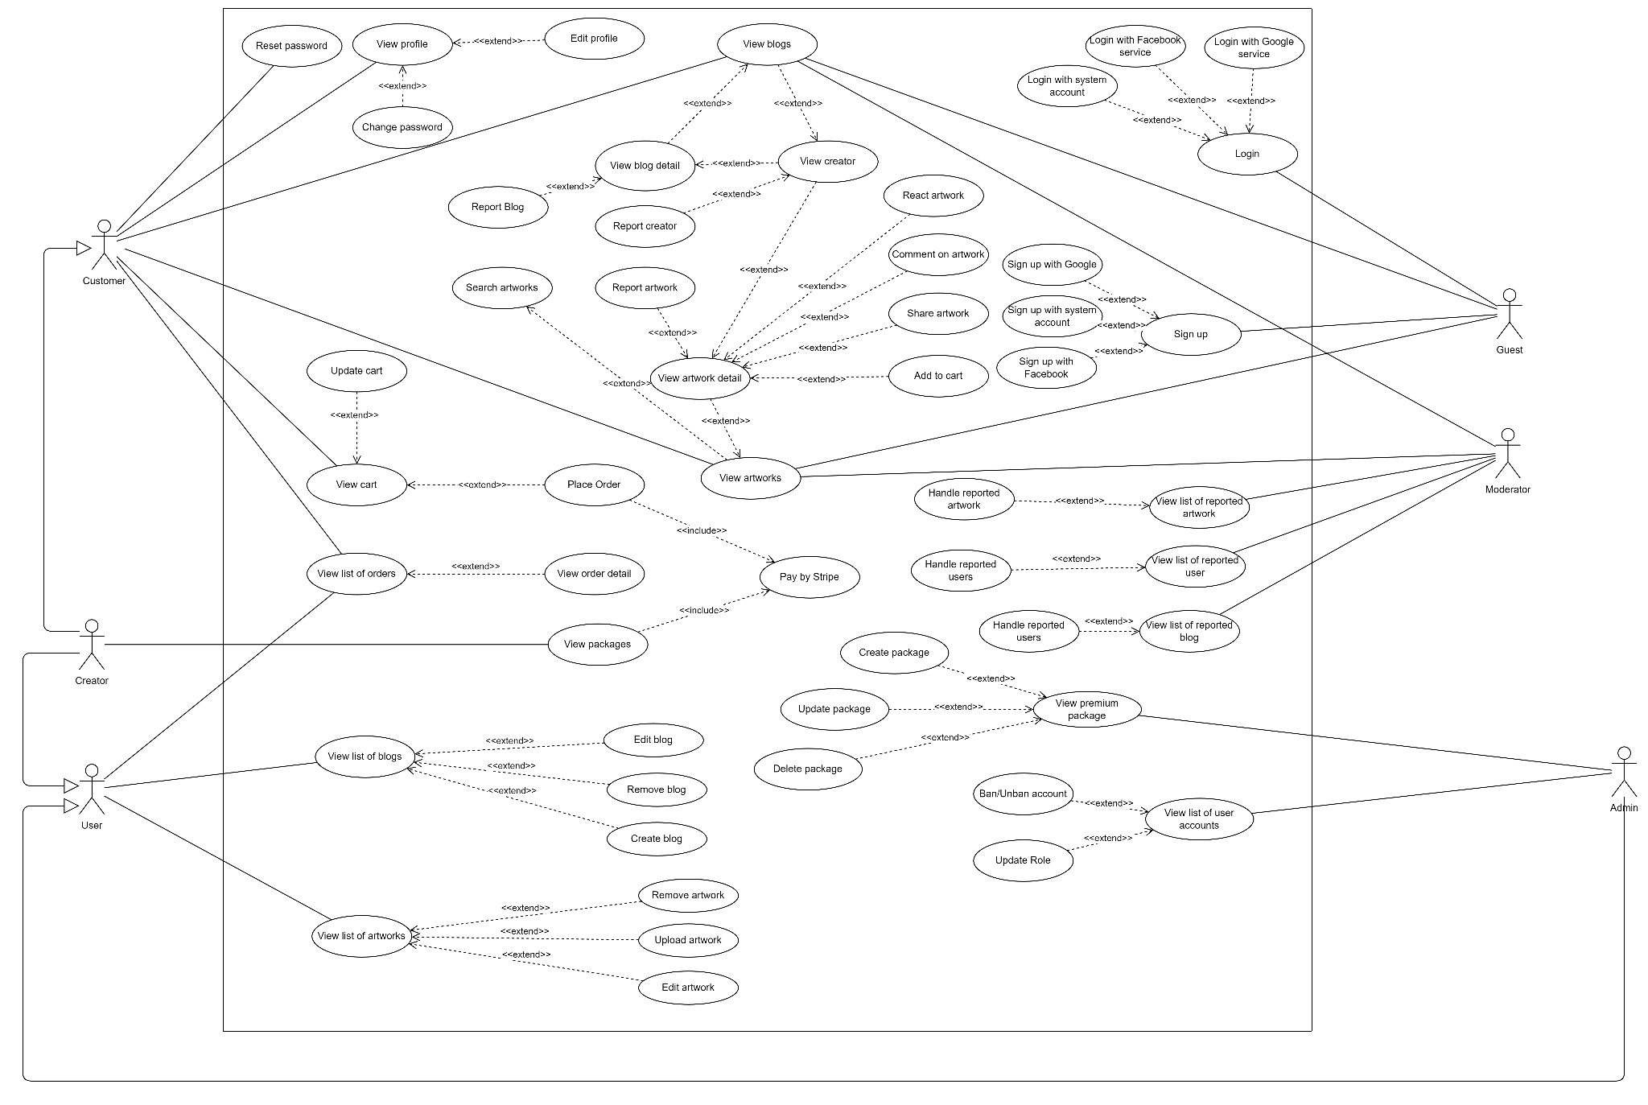

## Login

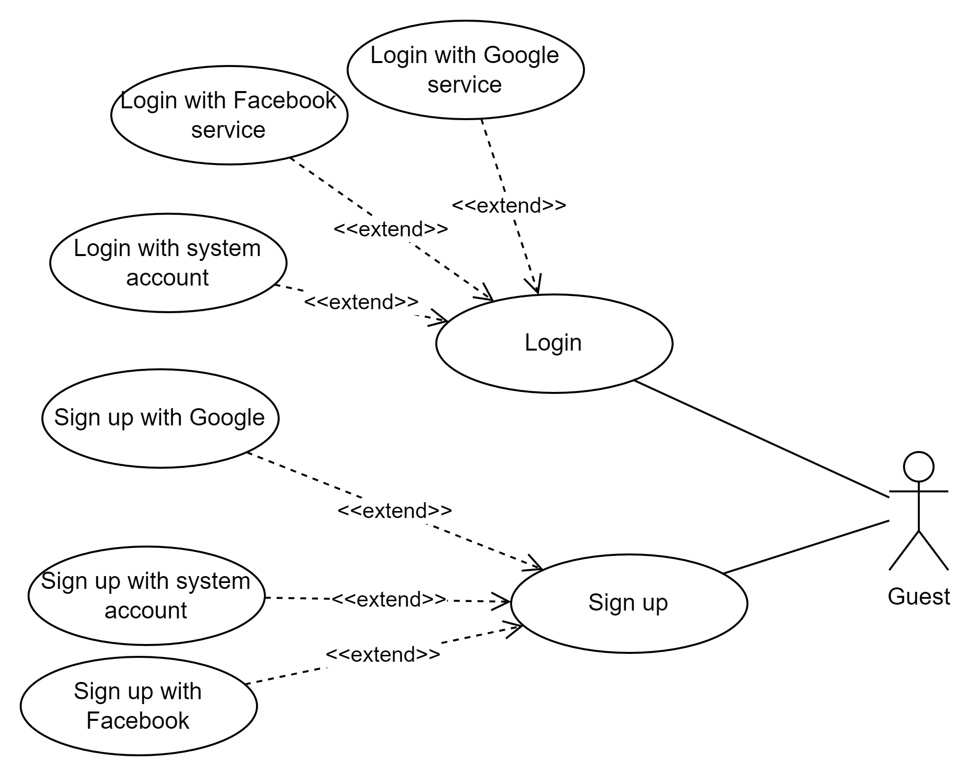

| **USE CASE-1 SPECIFICATION** | | | | |
| --- | --- | --- | --- | --- |
| **Use-case No.** | UC001 | **Use-case Version** | | <1.0> |
| **Use-case Name** | **Login** | | | |
| **Author** | Nguyen Huu Minh Tai | | | |
| **Date** | 25/02/2024 | **Priority** | High | |
| **Actor:**  *Guest.*  **Summary:**  *This use case describes the process of guests who want to log in to the Web Application.*  **Goal:**  *This feature allows the actor (Guest) to login to the Web Application.*  **Triggers**  *The actor (Guest) wants to log in to a Web Application.*  **Preconditions:**  *The actor has a Facebook Account, Google Account or an account registered before.*  *The account used to log in must be authorized to access the system. The account must not be banned by the admin.*  **Post Conditions:**   * *The system must display 'Login successful!' and grants the user access to their authorized resources and functionalities based on their role and permissions.* * *The system successfully logs the login event.*   **Main Success Scenario:**     | ***Step*** | ***Actor Action*** | ***System Response*** | | --- | --- | --- | | *1* | *On the home page, the actor clicks the button “Login” on the header or view detailed artwork.* | *The system redirects to the login page and shows a form to log in with these fields:* ***Email****: text input, required, check email format.*  ***Password****: must not be empty.*  *Below the form, there are buttons provided to facilitate logging in with Facebook, Google, and a standard Login button for the traditional login method.* | | *2* | *In the login page, the actor inputs email and passwords.*  *[Alternative 1]*  *[Alternative 2]* | *The system validates all input fields.*  *[Exception 1]* | | *3* | *The actor clicks “Login”.* | *The system redirects to the homepage if the user is a customer, creator, or moderator, and to the dashboard if the user is an admin.*  *[Exception 2] [Exception 3]* |   **Alternative Scenario:**  *1:*   | ***Step*** | ***Actor Action*** | ***System Response*** | | --- | --- | --- | | *1* | *In the home page, the actor clicks the button “Login” on the header or view detailed artwork.* | *The system redirects to the login page.* | | *2* | *In the login page, Actor clicks on the Facebook icon.* | *The system redirects to the Facebook interface and shows a confirmation message.* | | *3* | *Actor clicks the “Yes” button.* | *The system redirects to the home page if the account has previously logged in.*  *If you have never logged in before, the system will redirect you to the register page.* |   *2:*   | ***Step*** | ***Actor Action*** | ***System Response*** | | --- | --- | --- | | *1* | *In the home page, the actor clicks the button “Login” on the header or view detailed artwork.* | *The system redirects to the login page.* | | *2* | *In the login page, Actor clicks on the Google icon.* | *The system redirects to the Google interface and shows a confirmation message.* | | *3* | *Actor clicks the “Yes” button.* | *The system redirects to the home page if the account has previously logged in.*  *If you have never logged in before, the system will redirect you to the register page.* |   **Exceptions:**     | ***No*** | ***Cause*** | ***System Response*** | | --- | --- | --- | | *1* | *The inputs are not in a valid format.* | *The system immediatly informs error under the incorrect inputs.* | | *2* | *The email or password is not correct* | *System informs “Invalid login attempt”.* | | *3* | *The actor clicks on the “Login” button with some missing fields.* | *The system redirects to the Login page and informs error under the incorrect inputs.* |   **Relationships:**   * *Login with Facebook service.* * *Login with Google service.* * *Login with a system account.*   **Business Rules:**   * *The email format must be valid and required.* * *The password is required.* * *The actor cannot login with they are banned by the admin.* * *The admin cannot login with Facebook or Google.* | | | | |

## Sign Up

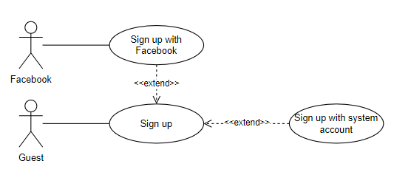

| **USE CASE-2 SPECIFICATION** | | | | |
| --- | --- | --- | --- | --- |
| **Use-case No.** | UC002 | **Use-case Version** | | <1.0> |
| **Use-case Name** | **Sign Up** | | | |
| **Author** | Nguyen Huu Minh Tai | | | |
| **Date** | 25/02/2024 | **Priority** | High | |
| **Actor:**  *Guest.*  **Summary:**  *This use case describes the process of guests who want to sign up for an account in a Web Application.*  **Goal:**  *This feature allows the actor (Guest) to create a new account to become a customer or creator in the system.*  **Triggers**  *The actor (Guest) wants to register an account in the web application.*  **Preconditions:**  *- The actor has a Facebook, Google or an Email account that has been authorized before.*  *- The actor does not have an account.*  *- The email must not have been signed up before.*  **Post Conditions:**  *- The system must display 'Login successful!' and grants the user access to their authorized resources and functionalities based on their role and permissions.*  *- The system must record user activity in the system log.*  **Main Success Scenario:**     | ***Step*** | ***Actor Action*** | ***System Response*** | | --- | --- | --- | | *1* | *On the home page, the actor clicks on the “Sign Up” button on the header.* | *The system redirects to the sign-up page and shows a form with these fields:*  ***Full Name:*** *text input cannot be empty.*  ***Email:*** *text input is required, check the email format.*  ***Gender:*** *select two options male or female.*  ***Select Role:*** *select two options customer or creator.*  ***Password/Confirm Password:*** *Two password input fields that must match, cannot be empty, must contain both letters and numbers, at least one special character, and at least one uppercase and one lowercase letter, with a length of more than 6 characters.* | | *2* | *The actor inputs all of the fields in the form sign-up.* | *The system validates all input data.*  *[Exception 1]* | | *3* | *The actor clicks on the “Sign Up” button.* | *The system sends an email to verify the email address. The actor clicks on "Clicking here" to verify the email, and then redirects to the homepage.*  *[Exception 2]*  *[Exception 3]* |   **Alternative Scenario:**  *1:*   | ***Step*** | ***Actor Action*** | ***System Response*** | | --- | --- | --- | | *1* | *The inputs are not in a valid format.* | *The system immediatly informs error under the incorrect inputs.* | | *2* | *The actor clicks the “Yes” button.* | *The system redirects to the home page.* |   *2:*   | ***Step*** | ***Actor Action*** | ***System Response*** | | --- | --- | --- | | *1* | *In the sign-up page, the actor clicks on the Google icon.* | *The system redirects to the Google interface and shows a confirmation message.* | | *2* | *The actor clicks the “Yes” button.* | *The system redirects to the home page.* |   **Exceptions:**     | ***No*** | ***Cause*** | ***System Response*** | | --- | --- | --- | | *1* | *The email and password are not in the correct format* | *The system redirects to the Sign Up page and informs error message to remind the user must input the correct format.* | | *2* | *The email already exists in the system.* | *The system redirects to the Sign Up page and displays a warning.* | | *3* | *The actor clicks on the “Sign Up” button with some missing fields.* | *The system redirects to the Sign Up page and informs error under the incorrect inputs.* |   **Relationships:**   * *Sign up with Facebook service.* * *Sign up with Google service.* * *Sign up with a system account.*   **Business Rules:**  *- Each account must have a unique email address.*  *- All inputs are required.*  *- The email format must be valid.*  *- Password / Confirmation Password : Two password input fields that must match, cannot be empty, must contain both letters and numbers, at least one special character, and at least one uppercase and one lowercase letter, with a length of more than 6 characters.* | | | | |

## 

## View profile

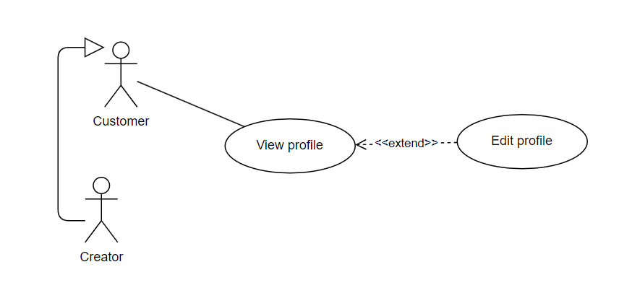

| **USE CASE-3 SPECIFICATION** | | | | |
| --- | --- | --- | --- | --- |
| **Use-case No.** | UC003 | **Use-case Version** | | <1.0> |
| **Use-case Name** | View profile | | | |
| **Author** | Dang Cong Hung | | | |
| **Date** | 25/02/2024 | **Priority** | High | |
| **Actor:**  *Creator, Customer.*  **Summary:**  *This use case describes the process of creators or customers viewing their own profile information including name, phone, email, address, and gender.*  **Goal:**  *Creators or customers are able to view their own profiles.*  **Triggers**  *Creators or customers click on the “Profile” option on the header.*  **Preconditions:**  *The actor must be authenticated and logged into the system as either a customer or a creator.*  **Post Conditions:**   * *Creators or customers successfully view their own profile information.* * *The system successfully displays the actor’s profile information.*   **Main Success Scenario:**     | ***Step*** | ***Actor Action*** | ***System Response*** | | --- | --- | --- | | *1.* | *1. The actor selects the “Hello” with the username option on the header.* | *1. The system redirects to the Manage Profile page, which displays personal information, including username, phone number, full name, gender, email, avatar and a password change section.*  *[Exception 1]* |   **Alternative Scenario:**  *N/A*  **Exceptions:**     | ***No*** | ***Cause*** | ***System Response*** | | --- | --- | --- | | *1* | *1. The system cannot access or find the user's profile information in the database.* | *1. The system displays an error message and instructs the user to try again later.* |   **Relationships:**  *Edit profile*  *Change password*  **Business Rules:**  *<Any concern about the business>* | | | | |
|  | | | | |

## 

## Edit profile

## 

| **USE CASE-4 SPECIFICATION** | | | | |
| --- | --- | --- | --- | --- |
| **Use-case No.** | UC004 | **Use-case Version** | | 1.0 |
| **Use-case Name** | Edit profile | | | |
| **Author** | Dang Cong Hung | | | |
| **Date** | 25/02/2024 | **Priority** | High | |
| **Actor:**  *Creator, Customer.*  **Summary:**  *This use case describes the process of creators or customers editing their own profile information.*  **Goal:**  *Creators or customers are able to edit their own profiles.*  **Triggers**  *Creators or customers click on the “Edit Profile” option on the profile page.*  **Preconditions:**  *- The user must be authenticated and logged into the system as either a customer or a creator.*  *- The actor must be on the Manage Profile Page.*  **Post Conditions:**  *- Creators or customers successfully edit their own profile information.*  *- Any changes made to the profile are reflected accurately upon return to the profile view.*  **Main Success Scenario:**     | ***Step*** | ***Actor Action*** | ***System Response*** | | --- | --- | --- | | *1* | *1. The actor selects “Edit Profile” option* | *1. The system displays a form containing fields for username, phone number, email, full name, avatar image, gender*  *[Username]: This field must be readonly.*  *[Full name]: It must not be empty and cannot contain numbers.*  *[Phone Number]: It must not be empty, must start with 0, and must have 10 digits.*  *[Email]: The email format must be valid.*  *[Gender]: It must be Male or Female.* | | *2* | *2. The actor inputs all of the fields in the form.* | *2. The system validates new information.*  *[Exception 1]* | | *3* | *3. The actor clicks the “Save” button.* | *3. The system redirects to the profile page, showing the new information.*  *[Exception 2]*  *[Exception 3]* |   **Alternative Scenario:**  *N/A*  **Exceptions:**     | ***No*** | ***Cause*** | ***System Response*** | | --- | --- | --- | | *1* | *1. The inputs are not in a valid format.* | *1. The system immediatly informs error under the incorrect inputs.* | | *2* | *2. The actor clicks on the “Save” button with some missing fields.* | *2. The system displays an error under which the field has not been inputted.* | | *3* | *3. The new and old emails are identical.* | *3. The systems redirect to the Profige page and display an error.* |   **Relationships:**  *View profile*  **Business Rules:**  *- The email format must be valid.*  *- The phone number must start with 0 and have 10 digits. - All inputs are required.* | | | | |

## Change password

## 

| **USE CASE-5 SPECIFICATION** | | | | |
| --- | --- | --- | --- | --- |
| **Use-case No.** | UC005 | **Use-case Version** | | 1.0 |
| **Use-case Name** | Change password | | | |
| **Author** | Dang Cong Hung | | | |
| **Date** | 25/02/2024 | **Priority** | High | |
| **Actor:**  *Creator, Customer.*  **Summary:**  *This use case describes the process of creators or customers changing their own password.*  **Goal:**  *Creators or customers are able to change their own password.*  **Triggers**  *Creators or customers click on the “Change password” section on the profile page.*  **Preconditions:**  *- The user must be authenticated and logged into the system as either a customer or a creator.*  *- The actor must be on the Manage Profile Page.*  **Post Conditions:**  *- Creators or customers successfully change their own password.*  *- The system saves the new password to the database.*  **Main Success Scenario:**     | ***Step*** | ***Actor Action*** | ***System Response*** | | --- | --- | --- | | *1* | *1. The actor selects “Change Password” section* | *1. The system displays a form containing fields for old password, new password and confirm password.*  ***Password/Confirm Password:*** *Two password input fields that must match, cannot be empty, must contain both letters and numbers, at least one special character, and at least one uppercase and one lowercase letter, with a length of more than 6 characters.* | | *2* | *2. The actor inputs all of the fields in the form.* |  | | *3* | *3. The actor clicks the “Save” button.* | *3. The system redirects to the profile page.*  *[Exception 1]*  *[Exception 2]*  *[Exception 3]*  *[Exception 4]* |   **Alternative Scenario:**  *N/A*  **Exceptions:**     | ***No*** | ***Cause*** | ***System Response*** | | --- | --- | --- | | *1* | *1. The inputs are not in a valid format.* | *1. The system informs error under the incorrect inputs.* | | *2* | *2. The password and confirmed password are not identical.* | *2. The system redirects to the Profile page and displays an error.* | | *3* | *3. The new and old emails are identical.* | *3. The systems redirect to the Profige page and display an error.* | | *4* | *4. The actor clicks on the “Save” button with some missing fields.* | *4. The system displays an error under which the field has not been inputted.* |   **Relationships:**  *View profile*  **Business Rules:**  *- Password / Confirmation Password : Two password input fields that must match, cannot be empty, must contain both letters and numbers, at least one special character, and at least one uppercase and one lowercase letter, with a length of more than 6 characters. - All inputs are required.*  *- The new and old password cannot be the same.* | | | | |

## View artworks

## 

| **USE CASE-6 SPECIFICATION** | | | | |
| --- | --- | --- | --- | --- |
| **Use-case No.** | UC006 | **Use-case Version** | | 1.0 |
| **Use-case Name** | View artworks | | | |
| **Author** | Dang Cong Hung | | | |
| **Date** | 25/02/2024 | **Priority** | Normal | |
| **Actor:**  *Creator, Customer, Guest, Moderator.*  **Summary:**  *This use case describes the process of creators or customers or guests or moderators viewing artworks on the homepage.*  **Goal:**  *The actor (Creator or Customer or Guest or Moderator) is able to view artworks on the homepage.*  **Triggers**  *The actor (Creator or Customer or Guest or Moderator) wants to view artworks.*  **Preconditions:**  *N/A*  **Post Conditions:**  *The systems successfully display the artworks on the homepage, showing only those artworks that have not been purchased.*  **Main Success Scenario:**     | ***Step*** | ***Actor Action*** | ***System Response*** | | --- | --- | --- | | *1* | *1. On the homepage, the actor clicks on the “Home” button.*  *[Alternative 1]* | *1. The system shows artworks that have not been purchased.*  *[Exception 1]* |   **Alternative Scenario:**     | ***Step*** | ***Actor Action*** | ***System Response*** | | --- | --- | --- | | *1* | *1. The actor clicks on the logo of the website.* | *1. The system shows artworks that have not been purchased.*  *[Exception 1]* |   **Exceptions:**     | ***No*** | ***Cause*** | ***System Response*** | | --- | --- | --- | | *1* | *- The result is empty.* | *The system displays an error message: “‘No data”.* |   **Relationships:**  *View artwork detail.*  *Search Artworks.*  **Business Rules:**   * *Each of the artwork must have a record in the storage and still be available.* * *All artwork information must be clear and up-to-date.* * *The artwork that has been bought will be hidden.* | | | | |

## 

## View artwork detail

## 

| **USE CASE-7 SPECIFICATION** | | | | |
| --- | --- | --- | --- | --- |
| **Use-case No.** | UC007 | **Use-case Version** | | 1.0 |
| **Use-case Name** | View artwork detail | | | |
| **Author** | Dang Cong Hung | | | |
| **Date** | 25/02/2024 | **Priority** | Normal | |
| **Actor:**  *Creator, Customer, Guest, Moderator.*  **Summary:**  *This feature allows the actor (Creator or Customer or Guest or Moderator) to view an artwork in detail.*  **Goal:**  *The actor (Creator or Customer or Guest or Moderator) can view an artwork in detail.*  **Triggers**  *The actor (Creator or Customer or Guest or Moderator) clicks on the “More” link in the artwork.*  **Preconditions:**  *The actor must be on the homepage or on an artwork detail page.*  **Post Conditions:**  *The system successfully displays the details of an artwork, along with like, share, report, and add to cart buttons, as well as a comment field.*  **Main Success Scenario:**     | ***Step*** | ***Actor Action*** | ***System Response*** | | --- | --- | --- | | *1* | *1. After the actor clicks on the “More” option in the picture of the artwork on the homepage.*  *[Alternative 1]* | *1. The system redirects to the artwork detail page. The page displays the artwork's detailed information such as:*   * *The creator’s name (a link).* * *Price.* * *Picture.* * *Description.* * *Title.*   *and shows like, share, report, add to cart buttons, and a comment field.*  *[Exception 1]* |   **Alternative Scenario:**  *1*   | ***Step*** | ***Actor Action*** | ***System Response*** | | --- | --- | --- | | *1* | *1. After the actor clicks on the “More” option in the picture of the different artwork on the artwork detail page in the “More Like This” section.* | *1. The system redirects to the artwork detail page. The page displays the artwork's detailed information such as:*   * *The creator’s name.* * *Price.* * *Picture.* * *Description.* * *Category.*   *and shows like, share, report, view creator, add to cart buttons, and a comment field.*  *The system shows some random artworks in the “More like this” section.*  *[Exception 1]* |   **Exceptions:**     | ***No*** | ***Cause*** | ***System Response*** | | --- | --- | --- | | *1* | *- The system cannot find the artwork detail in the database* | *The system displays an error message: “Artwork Detail not found”.* |   **Relationships:**  *- React artwork.*  *- Comment on artwork.*  *- Share artwork.*  *- Add to cart.*  *- Report artwork*  *- View creator*  **Business Rules:**  *N/A* | | | | |

## 

## Add to cart

## 

| **USE CASE-8 SPECIFICATION** | | | | |
| --- | --- | --- | --- | --- |
| **Use-case No.** | UC008 | **Use-case Version** | | <1.0> |
| **Use-case Name** | Add to cart | | | |
| **Author** | Dang Cong Hung | | | |
| **Date** | 25/02/2024 | **Priority** | High | |
| **Actor:**  *Creator, Customer.*  **Summary:**  *This use case describes the process of creators or customers adding an artwork to the cart.*  **Goal:**  *The actor (Creator or Customer) can add artwork to the cart.*  **Triggers**  *The actor (Creator or Customer) clicks on the “Add to cart” button.*  **Preconditions:**  *- The actor must be authenticated and logged into the system as either a customer or a creator.*  *- The actor should be viewing details of an artwork.*  **Post Conditions:**  *The system saves the artwork to the cart and redirects to the homepage.*  **Main Success Scenario:**     | ***Step*** | ***Actor Action*** | ***System Response*** | | --- | --- | --- | | *1* | *1. In the artwork detail page, the actor clicks on the “Add to cart” button.* | *1. The system saves the artwork to the cart.* |   **Alternative Scenario:**  *N/A*  **Exceptions:**  *N/A*  **Relationships:**  *View artwork detail*  **Business Rules:**  *The artwork must be available in stock. Creator can add his/her own artwork to his/her cart.* | | | | |
|  | | | | |

## Report artwork

## 

| **USE CASE-9 SPECIFICATION** | | | | | | | | | | | | |
| --- | --- | --- | --- | --- | --- | --- | --- | --- | --- | --- | --- | --- |
| **Use-case No.** | UC09 | | | | **Use-case Version** | | | | UC003 | | | |
| **Use-case Name** | Report artwork | | | | | | | | | | | |
| **Author** | Nguyen Tan Hung | | | | | | | | | | | |
| **Date** | 25/02/2024 | | | | **Priority** | | | | UC003 | | | |
| **Actor:**  *Customer, Creator.*  **Summary:**  *This use case describes when a customer or creator reports the artwork.*  **Goal:**  *As a customer or creator, I want to report the artwork in the detail page of it*  **Triggers**  *The customer or creator clicks on the "Report" button in the artwork detail page.*  **Preconditions**  *The user must be on the detail page of the artwork.*  **Post Conditions:**  *The information of the reported artwork must be shown on the “View Reported Artwork” page of the moderator role.*  **Main Success Scenario:**   | ***Step*** | ***Actor Action*** | ***System Response*** | | --- | --- | --- | | *1* | *Customer or Creator clicks on the report artwork button.* | *The system display the form showing type of report message and and two buttons: “Report / Cancel”.* | | *2* | *Customer or Creator choose a type of report* |  | | *3* | *Customer or Creator clicks on report button.* | *The system redirects to the artwork detail page.*  *[Exception 1]* |   **Alternative Scenario:**  *N/A.*  **Exceptions:**     | ***No*** | ***Cause*** | ***System Response*** | | --- | --- | --- | | *1* | *- The actor do not choose any type of report.* | *The system redirects to the form and displays an error.* |   **Relationships**  *View artwork detail*  **Business Rules:**   * *The function must be carried out by the creator or customer.* * *The information on the reported artwork must be saved in the database.* | | | | | | | | | | | | |

## 

## View list of artworks

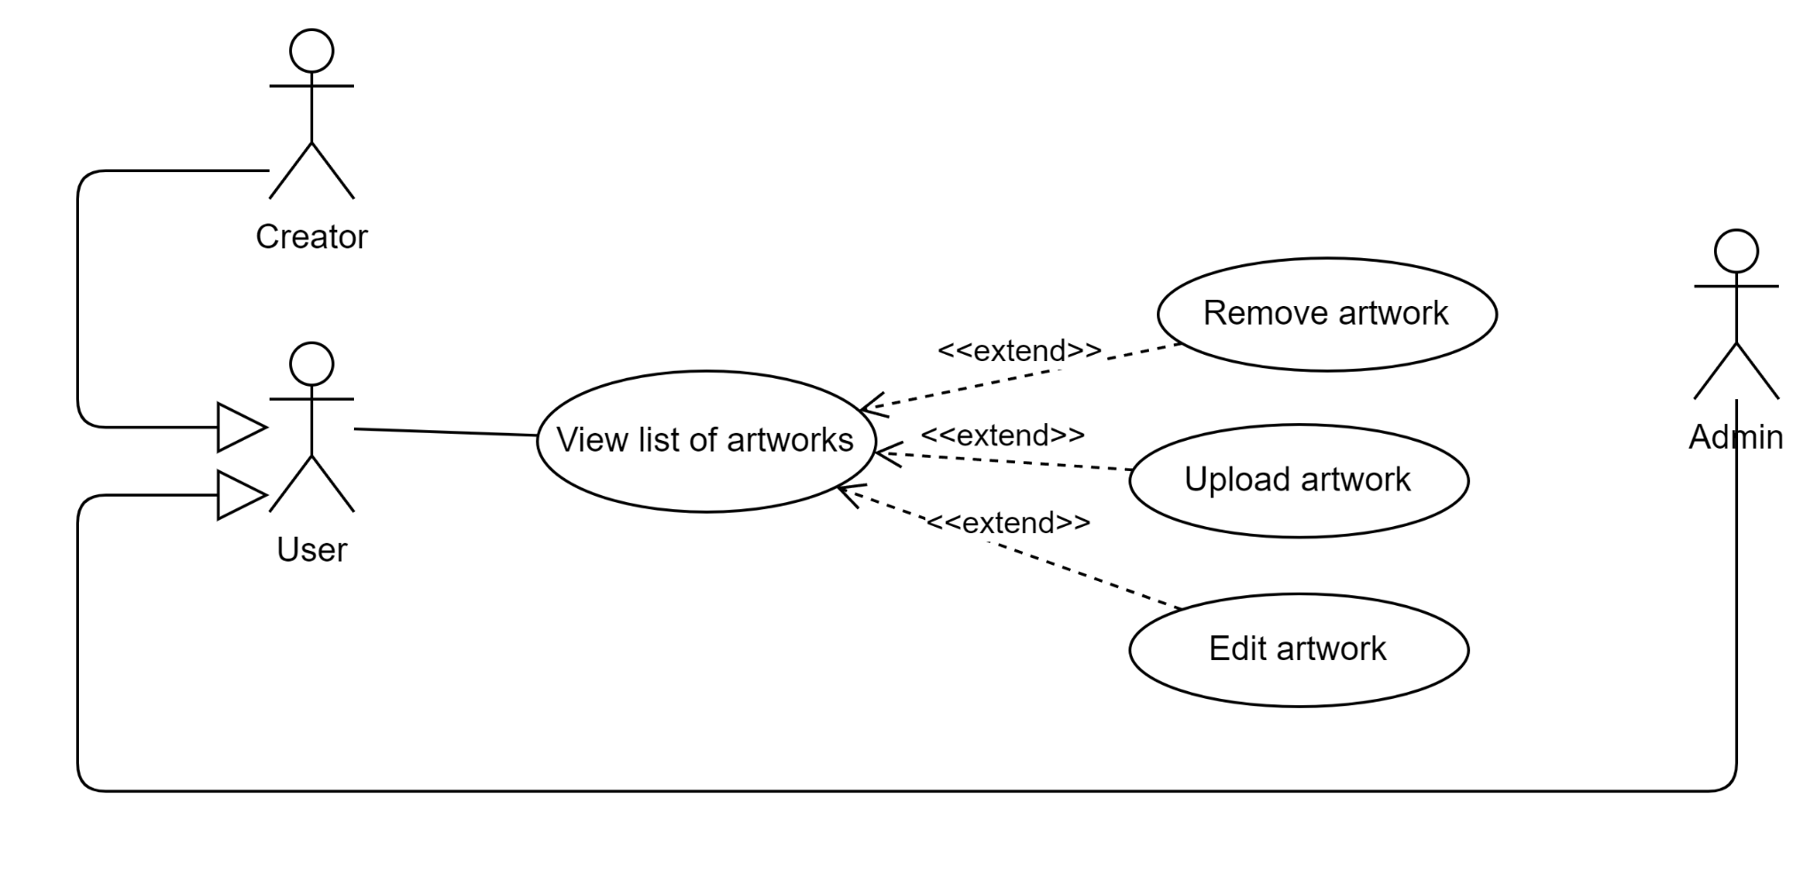

| **USE CASE-10 SPECIFICATION** | | | | |
| --- | --- | --- | --- | --- |
| **Use-case No.** | UC010 | **Use-case Version** | | <1.0> |
| **Use-case Name** | View list of artworks | | | |
| **Author** | Dang Cong Hung | | | |
| **Date** | 25/02/2024 | **Priority** | High | |
| **Actor:**  *Creator, Admin*  **Summary:**  *This use case describes the process of the creator or the admin viewing the list of artworks on the artwork list page.*  **Goal:**  *The Creator or The Admin is able to view the list of artworks on the artwork list page.*  **Triggers**  *The Creator or The Admin clicks on the “Manage Artworks” option on the header.*  **Preconditions:**  *- The user must be authenticated and logged into the system as either a creator or an admin.*  *- The creator must have the permission to view the list of artworks.*  **Post Conditions:**  *The system successfully displays a list of artworks on the “Artwork List” page, providing options to upload new artwork as well as edit and delete the existing ones, with corresponding buttons for each artwork entry.*  **Main Success Scenario:**     | ***Step*** | ***Actor Action*** | ***System Response*** | | --- | --- | --- | | *1* | *1. The actor clicks on the “Manage Artwork” option on the homepage.* | *1. The system displays the list of artworks, which includes the following details:*  *Price.*  *Title.*  *Description.*  *Category*  *Creator Name.*  *Additionally, there are buttons available for various actions:*  *For creators, they can view, edit and delete their own artworks, as well as to create new artwork.*  *For admins, all artworks are accessible for viewing, creating, editing, and deleting.* |   **Alternative Scenario:**  *N/A*  **Exceptions:**  *N/A*  **Relationships:**   * *Remove artwork* * *Upload artwork* * *Edit artwork.*   **Business Rules:**   * *For creators, they can view, edit and delete their own artworks, as well as to create new artwork.* * *For admins, all artworks are accessible for viewing, creating, editing, and deleting.* | | | | |

## 

## Remove artwork



| **USE CASE-10 SPECIFICATION** | | | | |
| --- | --- | --- | --- | --- |
| **Use-case No.** | UC0010 | **Use-case Version** | | <1.0> |
| **Use-case Name** | Remove artwork | | | |
| **Author** | Dang Cong Hung | | | |
| **Date** | 25/02/2024 | **Priority** | High | |
| **Actor:**  *Creator, Admin.*  **Summary:**  *This use case describes the process of the creator or the admin removing an artwork from the artwork list.*  **Goal:**  *The creator or the admin can remove an artwork.*  **Triggers**  *The creator clicks on the “Delete” button in a corresponding artwork.*  **Preconditions:**  *- The actor must be authenticated and logged into the system as either a creator or an admin.*  *- The actor must be on the Manage Artworks page.*  **Post Conditions:**   * *The system removes the artwork from the database and redirects to the Manage Artworks page.* * *Any changes made to the list of artworks are reflected accurately upon return to the Manage Artworks page.*   **Main Success Scenario:**     | ***Step*** | ***Actor Action*** | ***System Response*** | | --- | --- | --- | | *1* | *1. On the Manage Artwork page, the actor clicks the Delete button corresponding to the artwork.* | *1. The systems will show a popup box with the message: “Do you want to delete this artwork ?” and two buttons: “Yes / No”.*  *[Exception 1]* | | *2* | *2. The actor clicks on the “Yes” button.* | *2. The system removes the artwork from the database and redirects to the Manage Artwork page with the changes applied.*  *[Exception 2]* |   **Alternative Scenario:**  *N/A*  **Exceptions:**     | ***No*** | ***Cause*** | ***System Response*** | | --- | --- | --- | | *1* | *The actor clicks “No”.* | *The system redirects to the Manage Artworks page without any change.* | | *2* | *The artwork has already been bought.* | *The system displays an error message: “Artwork has been bought, cannot delete!”, then redirecting to the Manage Artwork.* |   **Relationships:**  *View the list of artworks.*  **Business Rules:**  *The actor cannot remove the artwork that has been bought.* | | | | |

## 

## 

## Upload artwork

## 

| **USE CASE-11 SPECIFICATION** | | | | |
| --- | --- | --- | --- | --- |
| **Use-case No.** | UC0011 | **Use-case Version** | | <1.0> |
| **Use-case Name** | Upload artwork | | | |
| **Author** | Dang Cong Hung | | | |
| **Date** | 25/02/2024 | **Priority** | High | |
| **Actor:**  *Creator*  **Summary:**  *This use case describes the process of the creator uploading an artwork to display on the homepage.*  **Goal:**  *The creator can upload an artwork.*  **Triggers**  *The creator clicks on the “Upload an artwork” button.*  **Preconditions:**  *- The actor must be authenticated and logged into the system as either a creator.*  *- The actor must be on the Manage Artworks page.*  **Post Conditions:**  *The system adds the artwork to the database and displays it on the homepage.*  **Main Success Scenario:**     | ***Step*** | ***Actor Action*** | ***System Response*** | | --- | --- | --- | | *1* | *1. The actor clicks on the “Upload an artwork” button on the Manage Artworks page.* | *1. The system displays a form for adding information about the artwork, including title, description, picture, price, a select box for "isPremium”, a dropdown for choosing category and buttons for "Create" and "Back to List."*  *- [Title] : Must not be empty.*  *- [Description] : Must be more than 50 letters.*  *- [Picture] : Must be a JPG file.*  *- [Price]: Must be a number.*  *- [Category]: Must choose one option.* | | *2* | *2. The actor inputs all of the fields in the form.* | *2. The system validates the information.*  *[Exception 1]* | | *3* | *3. The actor clicks on the “Image File” to choose the picture on the personal computer.* | *3. The system validates the image file.*  *[Exception 2]* | | *4* | *4. The actor clicks on the “Create” button* | *4. The system saves the information into the database and returns to the Manage Artworks Page.*  *[Exception 3] [Exception 4]* |   **Alternative Scenario:**  *N/A*  **Exceptions:**     | ***No*** | ***Cause*** | ***System Response*** | | --- | --- | --- | | *1* | *The actor inputs the information in the wrong format.* | *The system immediately displays an error message under the incorrectly formatted input.* | | *2* | *The actor chooses a file that is not an image.* | *The system displays an error message under the “Image File” button.* | | *3* | *The actor attempts to click "Create" with input that is incorrectly formatted, not an image, or both.* | *The system displays an error message under the incorrectly formatted input or the “Image File” button or both, prompting a redirection back to the form.* | | *4* | *The actor clicks on the “Create” button with some missing fields.* | *The system displays an error under which the field has not been inputted.* |   **Relationships:**  *N/A*  **Business Rules:**   * *The picture-choosing field must be the button to choose from a file or a personal computer.* * *All inputs are required.* * *The information format must be valid:* * *Price must be a number.* * *Description must be more than 50 letters.* * *Picture must be a jpg file.* | | | | |

## 

## View list of user accounts

## 

| **USE CASE-12 SPECIFICATION** | | | | |
| --- | --- | --- | --- | --- |
| **Use-case No.** | UC012 | **Use-case Version** | | <1.0> |
| **Use-case Name** | View list of user accounts | | | |
| **Author** | Dang Cong Hung | | | |
| **Date** | 25/02/2024 | **Priority** | High | |
| **Actor:**  *Admin.*  **Summary:**  *This use case describes the process of the admin viewing a list of user accounts in the system.*  **Goal:**  *The admin can view a list of user accounts.*  **Triggers**  *The admin clicks the “Manage Users” button.*  **Preconditions:**  *The actor must be authenticated and logged into the system as an admin.*  **Post Conditions:**  *The system shows a list of user accounts with name, phone number, email, a ban/unbanned icon and a permission button.*  **Main Success Scenario:**     | ***Step*** | ***Actor Action*** | ***System Response*** | | --- | --- | --- | | *1* | *1. In the homepage, the actor clicks on the “Manage Users” option.* | *1. System redirects to the Manage Users page and shows a list of user accounts with name, phone number, email, a ban/unbanned icon and a permission button.* |   **Alternative Scenario:**  *N/A*  **Exceptions:**  *N/A*  **Relationships:**  *Remove account*  **Business Rules:**  *<Any concern about the business>* | | | | |
|  | | | | |

## Update role

## 

| **USE CASE-12 SPECIFICATION** | | | | |
| --- | --- | --- | --- | --- |
| **Use-case No.** | UC012 | **Use-case Version** | | <1.0> |
| **Use-case Name** | Update role | | | |
| **Author** | Nguyen Tan Hung | | | |
| **Date** | 25/02/2024 | **Priority** | High | |
| **Actor:**  *Admin.*  **Summary:**  *This use case describes the process of the admin changes the role of a user.*  **Goal:**  *The admin can change the role of a chosen user in the “List of users” page.*  **Triggers**  *The admin clicks the “Manage Users” button.*  **Preconditions:**   * *The actor must be authenticated and logged into the system as an admin.* * *The admin must view the list of users first.*   **Post Conditions:**   * *The system changes the role of the selected user.* * *Users whose roles are changed can do new functions.*   **Main Success Scenario:**     | ***Step*** | ***Actor Action*** | ***System Response*** | | --- | --- | --- | | *1* | *1. Admin clicks on the “Permission” button next to the selected user to change the role in the “View list users” page.* | *The system displays information about the selected user. [User Name], [Role]* | | *2* | *The admin selects the new user's role using the drop-down list.* |  | | *3* | *The Admin clicks the “Save” button to update the user's role.* | *The system updates the new user’s role and shows the list of users with the updated database.* |   **Alternative Scenario:**  *N/A*  **Exceptions:**     | ***No*** | ***Cause*** | ***System Response*** | | --- | --- | --- | | *1* | *The admin changes the role of himself.* | *The system displays an error: “Cannot change your role”.* |   **Relationships:**  *Ban/Unban account*  *View list user*  **Business Rules:**  *Only the admin can process this use case.* | | | | |

## View list of blogs

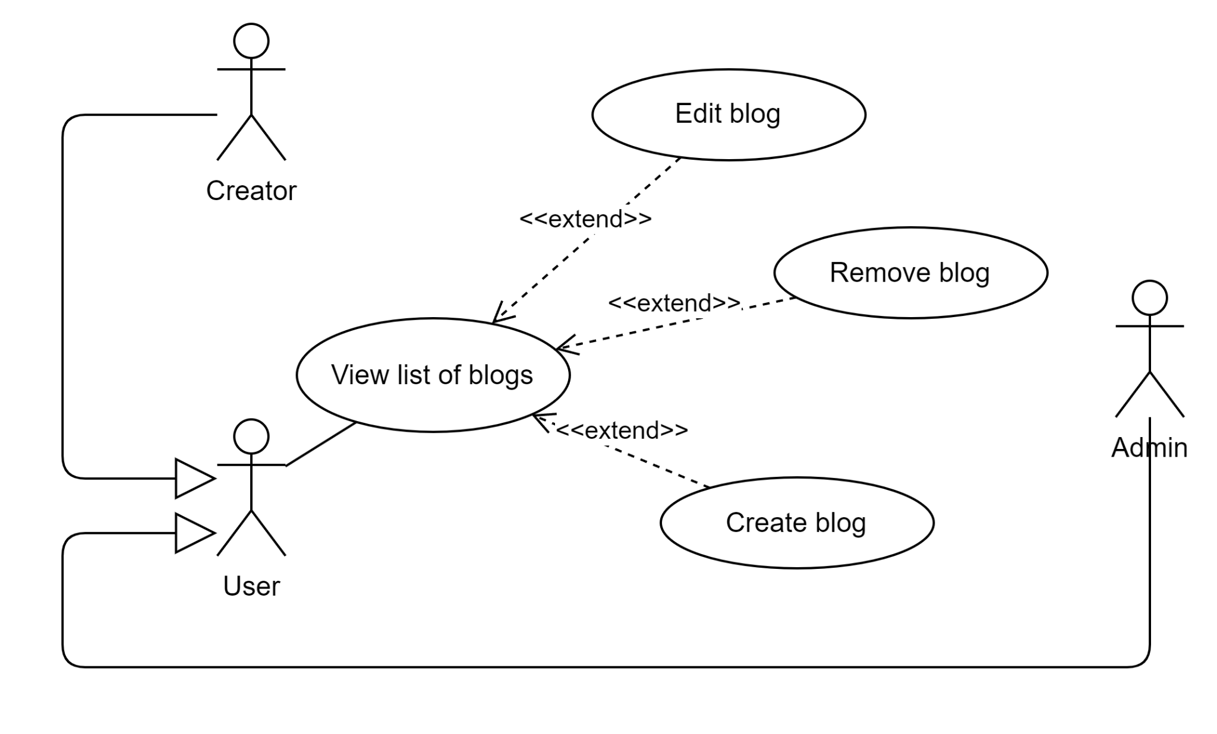

| **USE CASE-20 SPECIFICATION** | | | | | | | | | | | | |
| --- | --- | --- | --- | --- | --- | --- | --- | --- | --- | --- | --- | --- |
| **Use-case No.** | UC020 | | | | **Use-case Version** | | | | UC003 | | | |
| **Use-case Name** | View list of blogs | | | | | | | | | | | |
| **Author** | Nguyen Tan Hung | | | | | | | | | | | |
| **Date** | 25/02/2024 | | | | **Priority** | | | | UC003 | | | |
| **Actor:**  *Creator, admin*  **Summary:**  *This use case describes the process of a creator viewing his blog and an admin viewing all artwork in the application.*  **Goal:**  *As a creator, I want to see the list of my blogs.*  *As an admin, I want to see the list of all blogs.*  **Triggers**  *The creator or admin clicks the “Blog list” to activate this function.*  **Preconditions**  *The user must have previously logged in with a creator or admin account on the system.*  **Post Conditions**  *Displays a list of blogs. The administrator can click a button next to do more related functions.*  **Main Success Scenario:**   | ***Step*** | ***Actor Action*** | ***System Response*** | | --- | --- | --- | | *1* | *The creator or admin clicks the “View Blogs” button.* | *The system displays a list of reported users in the app on the website based on their role.*   * *Creator: Display the list of blogs that belong to him.* * *Admin: Display the list of all blogs in the application.* |   **Alternative Scenario**  *N/A.*  **Exceptions**  *N/A.*  **Relationships**  *Create blog, Edit blog, Delete blog.*  **Business Rules:**   * *Only the creator or admin can do this use case.* * *The blogs displayed must based on the user's role* | | | | | | | | | | | | |

## 

## Create blog posts



| **USE CASE-20 SPECIFICATION** | | | | | | | | | | | | |
| --- | --- | --- | --- | --- | --- | --- | --- | --- | --- | --- | --- | --- |
| **Use-case No.** | UC020 | | | | **Use-case Version** | | | | UC003 | | | |
| **Use-case Name** | Create blog posts | | | | | | | | | | | |
| **Author** | Nguyen Tan Hung | | | | | | | | | | | |
| **Date** | 25/02/2024 | | | | **Priority** | | | | UC003 | | | |
| **Actor:**  *Creator*  **Summary:**  *This use case describes the process of a creator creating a blog post.*  **Goal:**  *As a creator, I want to create a blog post.*  **Triggers**  *The creator clicks the “Create blog” on the “View list of blogs” page to activate this function.*  **Preconditions**  *The user has access to the “View list of blogs” page.*  **Post Conditions**  *Create a new blog and display it on the “Blogs” page.*  **Main Success Scenario:**   | ***Step*** | ***Actor Action*** | ***System Response*** | | --- | --- | --- | | *1* | *The admin clicks “Create blog”* | *The system displays the form to fill in the ìnormation of the new blog on the website.*   * *[Title]: Must not be empty.* * *[Description]: Must be more than 50 letters.* * *[Picture]: Must be a JPG file.* * *[Price]: Must be a number.* * *[Category]: Must choose one option.* | | *2* | *The admin enters the new information about the blog.* | *The system verifies the new information of the blog being entered.* | | *3* | *The admin clicks submit the new information.* | *The system updates the new information to the database and shows the successful message.* |   **Alternative Scenario**  *N/A.*  **Exceptions:**   | ***Step*** | ***Actor Action*** | ***System Response*** | | --- | --- | --- | | *1* | *The user inputs invalid information in the form.* | *The system displays the error and pretends the user to create the new blog.* |   **Relationships**  *View list of blogs.*  **Business Rules:**   * *Only the creator can do this use case.* * *The blogs displayed must based on the user's role* | | | | | | | | | | | | |

## Update blog posts



| **USE CASE-21 SPECIFICATION** | | | | | | | | | | | | |
| --- | --- | --- | --- | --- | --- | --- | --- | --- | --- | --- | --- | --- |
| **Use-case No.** | UC021 | | | | **Use-case Version** | | | | UC003 | | | |
| **Use-case Name** | Update blog posts | | | | | | | | | | | |
| **Author** | Nguyen Tan Hung | | | | | | | | | | | |
| **Date** | 25/02/2024 | | | | **Priority** | | | | UC003 | | | |
| **Actor:**  *Creator.*  **Summary:**  *This use case describes how a creator can update the information of one of his blog post.*  **Goal:**  *As a creator, I want to update the information of my blog post.*  **Triggers**  *The creator clicks the “Update blog” to activate this function.*  **Preconditions**  *The user must have previously logged in with a creator account on the system and in the “View list of blogs”.*  **Post Conditions**  *Blog updated by the creator will display the new information on the Blog page.*  **Main Success Scenario:**   | ***Step*** | ***Actor Action*** | ***System Response*** | | --- | --- | --- | | *1* | *The Creator clicks the “Update” button next to the blog the creator wants to update information on.* | *The system displays the current information of the package being clicked by the admin on the website.*   * *[Title]: Must not be empty.* * *[Description]: Must be more than 50 letters.* * *[Picture]: Must be a JPG file.* * *[Price]: Must be a number.* * *[Category]: Must choose one option.* | | *2* | *The creator changes the information of the blog.* | *The system verifies the new information of the blog being entered.* | | *3* | *The creator clicks submit the new information.* | *The system updates the new information to the database.* |   **Alternative Scenario**  *N/A.*  **Exceptions:**   | ***Step*** | ***Actor Action*** | ***System Response*** | | --- | --- | --- | | *1* | *The user inputs invalid information in the form.* | *The system displays an error and prevents the process from saving new information.* |   **Relationships**  *View list of blogs.*  **Business Rules:**   * *The new information in the blog must be valid.* * *Only the creator can update the blog.* | | | | | | | | | | | | |

## 

## Remove blog



| **USE CASE-23 SPECIFICATION** | | | | | | | | | | | | |
| --- | --- | --- | --- | --- | --- | --- | --- | --- | --- | --- | --- | --- |
| **Use-case No.** | UC023 | | | | **Use-case Version** | | | | UC003 | | | |
| **Use-case Name** | Remove blog post | | | | | | | | | | | |
| **Author** | Nguyen Tan Hung | | | | | | | | | | | |
| **Date** | 25/02/2024 | | | | **Priority** | | | | UC003 | | | |
| **Actor:**  *Creator, Admin*  **Summary:**  *This use case describes how the creator or admin can delete a blog post in the application.*  **Goal:**  *As a creator, I want to delete my blog from the web application.*  *As an admin, I want to delete any blog in the web application.*  **Triggers**  *The admin clicks the “Remove” to activate this function.*  **Preconditions**   * *The user must have previously logged in with an admin account on the system.* * *The user must be on the View blog page.*   **Post Conditions**  *Packages deleted by the administrator will not display on the application.*  **Main Success Scenario:**   | ***Step*** | ***Actor Action*** | ***System Response*** | | --- | --- | --- | | *1* | *The actor clicks on the “Remove” button on the corresponding blog post.* | *The system asks the actor to confirm the process to delete the blog post from the database.* | | *2* | *The actor clicks “Yes” to confirm.* | *The system deletes the blog post from the database and shows the successful notification.* |   **Alternative Scenario**  *N/A.*  **Exceptions:**   | ***Step*** | ***Actor Action*** | ***System Response*** | | --- | --- | --- | | *1* | *The user selects “No” when the system confirms.* | *The system still keeps the database of the blog post.* |   **Relationships**  *View list of blogs.*  **Business Rules:**  *Only the admin can update the package.* | | | | | | | | | | | | |

## 

## View Reported User

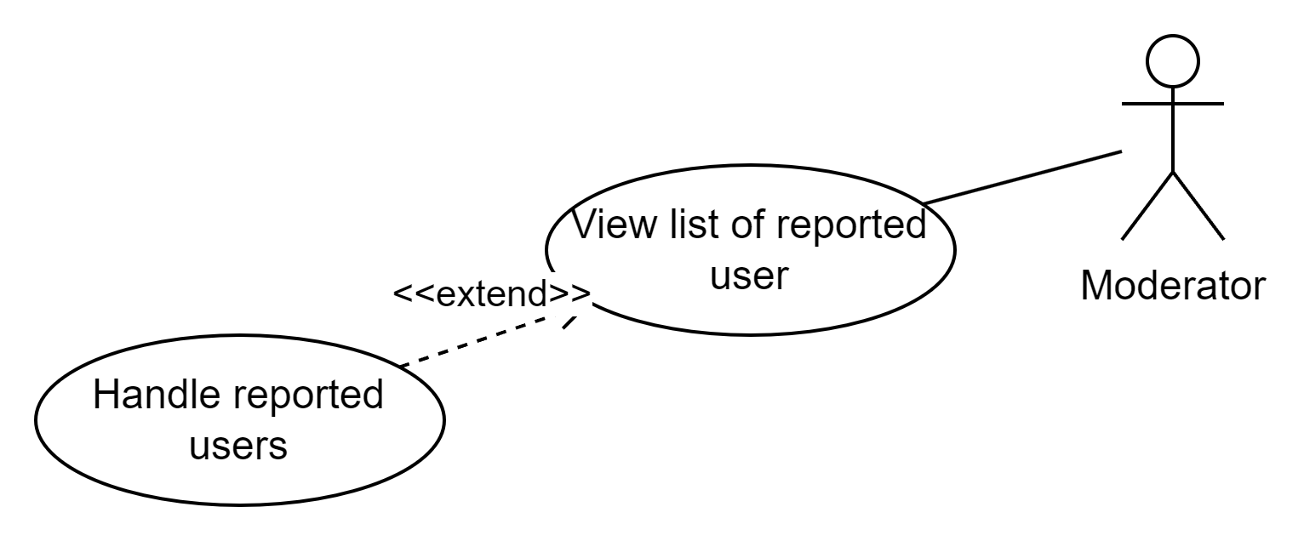

| **USE CASE-20 SPECIFICATION** | | | | | | | | | | | | |
| --- | --- | --- | --- | --- | --- | --- | --- | --- | --- | --- | --- | --- |
| **Use-case No.** | UC020 | | | | **Use-case Version** | | | | UC003 | | | |
| **Use-case Name** | View Reported User | | | | | | | | | | | |
| **Author** | Nguyen Tan Hung | | | | | | | | | | | |
| **Date** | 25/02/2024 | | | | **Priority** | | | | UC003 | | | |
| **Actor:**  *Moderator*  **Summary:**  *This use case describes the process of a moderator viewing reports about the reported user by a user*  **Goal:**  *As a moderator, I want to see the list of reported users on the application.*  **Triggers**  *The moderator clicks the “Reported User” to activate this function.*  **Preconditions**  *The user must have previously logged in with a moderator account on the system.*  **Post Conditions**  *Displays a list of reported users. The administrator can click a button to handle the reported user*  **Main Success Scenario:**   | ***Step*** | ***Actor Action*** | ***System Response*** | | --- | --- | --- | | *1* | *The Moderator clicks the “Reported User” button.* | *The system displays a list of reported users in the app on the website.*  *[Artist Id], [Artist Name], [Ban artist button]* |   **Alternative Scenario**  *N/A.*  **Exceptions:**   | ***Step*** | ***Actor Action*** | ***System Response*** | | --- | --- | --- | | *1* | *The Moderator removes the post/user that another moderator is deleting.* | *The system displays an error message.* |   **Relationships**  *View report.*  **Business Rules:**  *Only the moderator can handle the reported post.* | | | | | | | | | | | | |

## 

## Ban/Unban account

## 

| **USE CASE-13 SPECIFICATION** | | | | |
| --- | --- | --- | --- | --- |
| **Use-case No.** | UC013 | **Use-case Version** | |  |
| **Use-case Name** | Ban/Unban account | | | |
| **Author** | Dang Cong Hung | | | |
| **Date** | 25/02/2024 | **Priority** | High | |
| **Actor:**  *Admin.*  **Summary:**  *This use case describes the process of the admin banning/ unbanning a user account.*  **Goal:**  *The admin can ban/unban a user account.*  **Triggers**  *The admin clicks on the “Ban” or “Unban” button.*  **Preconditions:**  *- The actor must be authenticated and logged into the system as an admin.*  *- The actor must be in the Manage Users page.*  *- The user account status must not be false.*  **Post Conditions:**  *- The system saves the status of the user account to be false.*  *- The user of the banned account cannot log in to the system.*  **Main Success Scenario:**     | ***Step*** | ***Actor Action*** | ***System Response*** | | --- | --- | --- | | *1* | *1. On the Manage Users page, the actor clicks on the Ban or Unban button of a corresponding user.* | *1. System changes the status of that user to false, saves it in the database, and informs: “Ban successfully”;*  *[Exception 1]* |   **Alternative Scenario:**  *N/A*  **Exceptions:**     | ***No*** | ***Cause*** | ***System Response*** | | --- | --- | --- | | *1* | *The admin bans an admin account.* | *The system displays an error message: ”Admin cannot be banned”.* |   **Relationships:**  *View list of user accounts.*  **Business Rules:**   * *When a user account is banned, its status will be changed to false.* | | | | |

## Reset password

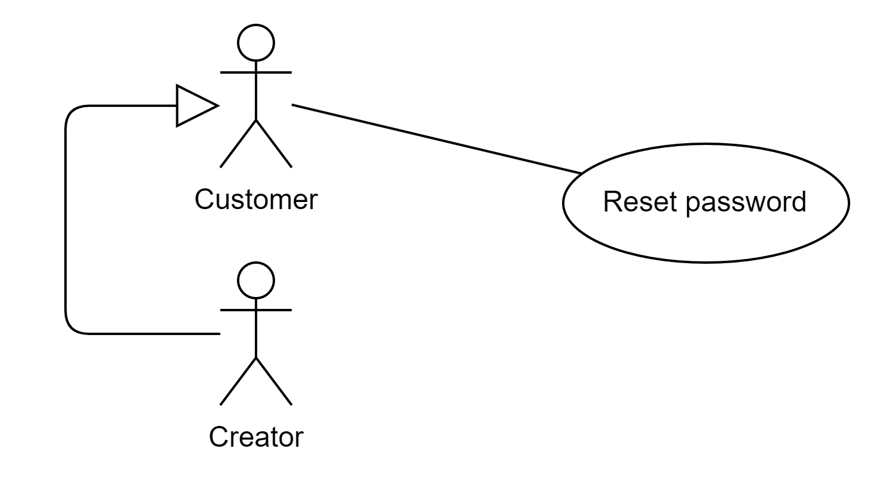

| **USE CASE-15 SPECIFICATION** | | | | | | | | | | | | |
| --- | --- | --- | --- | --- | --- | --- | --- | --- | --- | --- | --- | --- |
| **Use-case No.** | UC015 | | | | **Use-case Version** | | | | 1.0 | | | |
| **Use-case Name** | Reset password | | | | | | | | | | | |
| **Author** | Nguyen Tan Hung | | | | | | | | | | | |
| **Date** | 05/02/2024 | | | | **Priority** | | | | High | | | |
| **Actor:**  *Customer, creator.*  **Summary:**  *To allow users to securely reset their forgotten passwords and regain access to their accounts.*  **Goal:**  *As a customer or creator, I want to reset my password to regain access to the web application when I forget my password.*  **Triggers**  *The user clicks "Forgot Password" on the login page.*  **Preconditions:**  *The user must have previously registered an account on the system.*  **Post Conditions:**  *The user successfully resets their password and gains access to their account.*  **Main Success Scenario:**     | ***Step*** | ***Actor Action*** | ***System Response*** | | --- | --- | --- | | *1* | *The user clicks the "Forgot Password" option on the login page.* | *The system displays the "Forgot Password" form. The fields must not be empty.*   * *[Email]: Should follow a valid email format* * *[New password]: contain an uppercase character, lowercase character, a digit, and a non-alphanumeric character. Passwords must be at least six characters long.* * *[Confirm new password]: Must match the new password field.* | | *2* | *The user enters and submits their email address* | *The system validates the email address. The system generates a unique reset link and sends it to the user's email.* | | *3* | *The User receives the reset email and clicks on the reset link.* | *The system directs the user to the password reset page.* | | *4* | *The user enters a new password and confirms it.* | *The system validates and updates the password for the user's account and allows the customer to log in with the new password.* |   **Alternative Scenario:**  *N/A*  **Exceptions:**   | ***Step*** | ***Actor Action*** | ***System Response*** | | --- | --- | --- | | *1* | *The user enters and submits the wrong email address* | *The system displays the error and demands the user input again.* | | *2* | *The new passwords are not available.* | *The system shows the message to alert the user.* | | *3* | *The confirm password in the “Reset password” page is not the same as the password.* | *The system shows the message to alert the user.* |   **Relationships:**  *N/A*  **Business Rules:**   * *Password reset links should expire after a certain time (e.g., 24 hours) to ensure security.* * *Users may be limited to a certain number of password reset attempts within a specific timeframe to prevent abuse.* | | | | | | | | | | | | |

## 

## Report creator

## 

| **USE CASE-16 SPECIFICATION** | | | | | | | | | | | | |
| --- | --- | --- | --- | --- | --- | --- | --- | --- | --- | --- | --- | --- |
| **Use-case No.** | UC016 | | | | **Use-case Version** | | | | 1.0 | | | |
| **Use-case Name** | Report creator | | | | | | | | | | | |
| **Author** | Nguyen Tan Hung | | | | | | | | | | | |
| **Date** | 05/02/2024 | | | | **Priority** | | | | High | | | |
| **Actor:**  *Customer, creator.*  **Summary:**  *This use case describes when a customer or creator reports the creator.*  **Goal:**  *As a customer or creator, I want to report the creator.*  **Triggers**  *The customer or creator clicks on the "Report" button in the creator page.*  **Preconditions:**  *The user must be on the creator page.*  **Post Conditions:**  *The user successfully resets their password and gains access to their account.*  **Main Success Scenario:**   | ***Step*** | ***Actor Action*** | ***System Response*** | | --- | --- | --- | | *1* | *Customer or Creator clicks on the report creator button.* | *The system display the form showing type of report message and and two buttons: “Report / Cancel”.* | | *2* | *Customer or Creator choose a type of report* |  | | *3* | *Customer or Creator clicks on report button.* | *The system redirects to the creator profilel page.*  *[Exception 1]* |   **Alternative Scenario:**  *N/A*  **Exceptions:**     | ***No*** | ***Cause*** | ***System Response*** | | --- | --- | --- | | *1* | *- The actor do not choose any type of report.* | *The system redirects to the form and displays an error.* |   **Relationships:**  *N/A*  **Business Rules:**   * *The function must be carried out by the creator or customer.* * *The information on the reported creator must be saved in the database.* | | | | | | | | | | | | |

## 

## View premium package

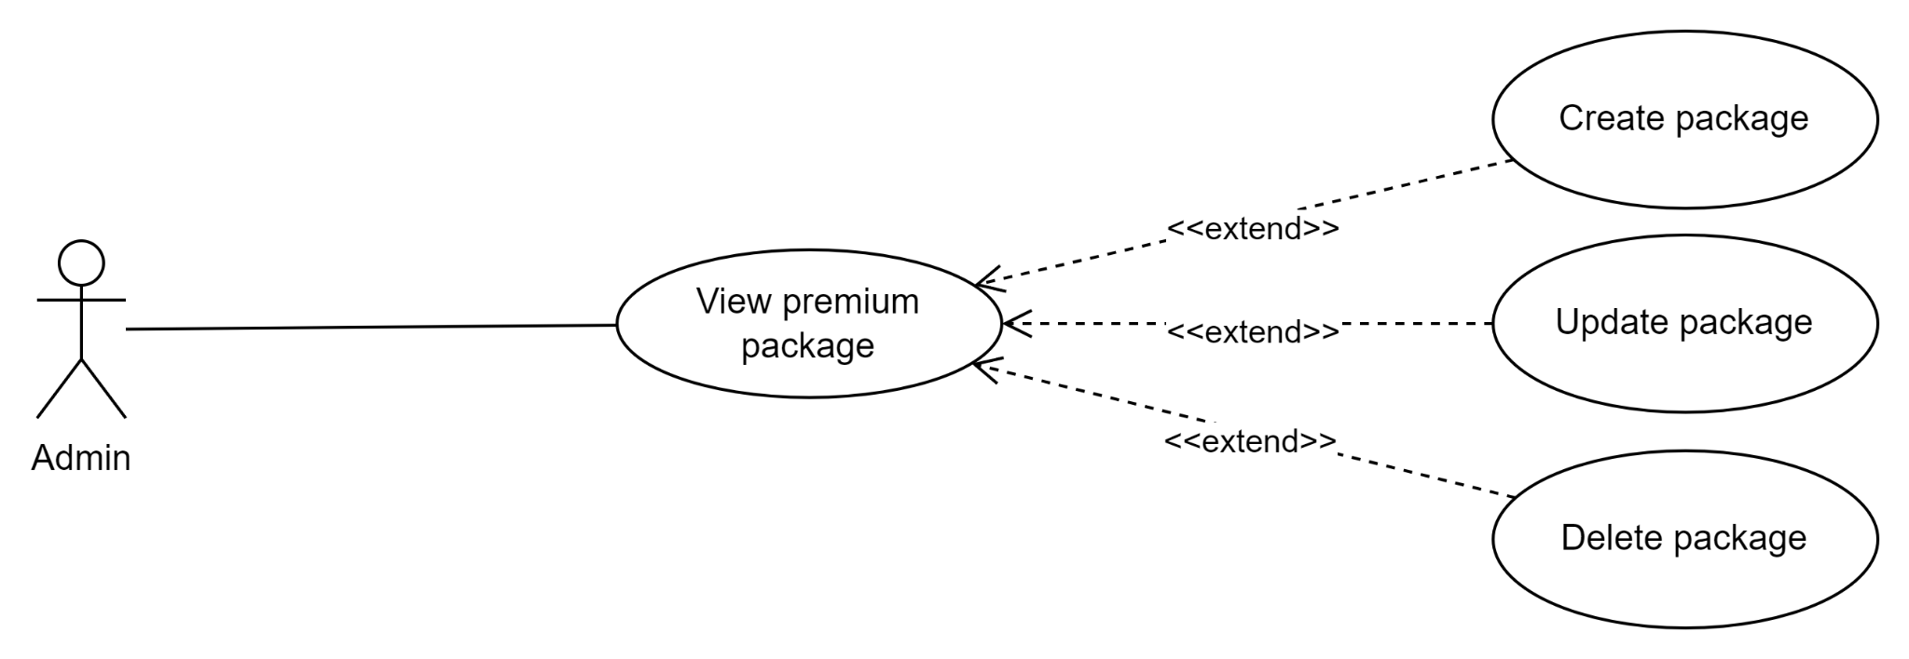

| **USE CASE-18 SPECIFICATION** | | | | | | | | | | | | |
| --- | --- | --- | --- | --- | --- | --- | --- | --- | --- | --- | --- | --- |
| **Use-case No.** | UC018 | | | | **Use-case Version** | | | | UC003 | | | |
| **Use-case Name** | View premium package | | | | | | | | | | | |
| **Author** | Nguyen Tan Hung | | | | | | | | | | | |
| **Date** | 25/02/2024 | | | | **Priority** | | | | UC003 | | | |
| **Actor:**  *Admin*  **Summary:**  *This method describes how the admin can view and modify the package.*  **Goal:**  *As an admin, I want to view and modify the premium package for the user in the web application*  **Triggers**  *The user activates the method possessed by selecting the “View package” option on the header.*  **Preconditions**  *The user must have logged in with an admin role account on the system previously*  **Post Conditions:**   * *The admin can view the overall package on the site.* * *The admin can choose the package to edit its information.*   **Main Success Scenario:**   | ***Step*** | ***Actor Action*** | ***System Response*** | | --- | --- | --- | | *1* | *The admin clicks “View package”.* | *The system displays the package list and its information on the site.*  *[Package name], [Price], [Amout artwork], [Description], [Edit button]* |   **Alternative Scenario**  *N/A.*  **Exceptions**  *N/A.*  **Relationships**  *Update package.*  **Business Rules:**  *Only the admin can view the list of the package.* | | | | | | | | | | | | |

## 

## View Reported Artwork

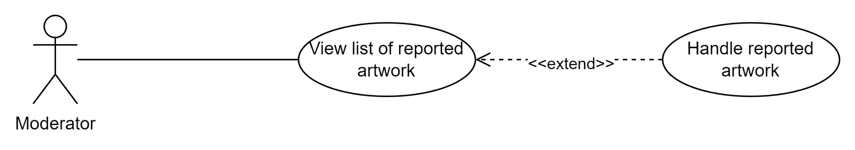

| **USE CASE-19 SPECIFICATION** | | | | | | | | | | | | |
| --- | --- | --- | --- | --- | --- | --- | --- | --- | --- | --- | --- | --- |
| **Use-case No.** | UC019 | | | | **Use-case Version** | | | | UC003 | | | |
| **Use-case Name** | View Reported Artwork | | | | | | | | | | | |
| **Author** | Nguyen Tan Hung | | | | | | | | | | | |
| **Date** | 25/02/2024 | | | | **Priority** | | | | UC003 | | | |
| **Actor:**  *Moderator*  **Summary:**  *This use case describes the process of a moderator viewing reports about artwork by a user*  **Goal:**  *As a moderator, I want to see the list of reported artwork on the application.*  **Triggers**  *The user activates the handle reported artwork possessed by clicking the “Reported Artwork” link.*  **Preconditions**  *The user must have previously logged in with a moderator account on the system.*  **Post Conditions:**  *The artwork deleted by the moderator cannot appear in the application.*  **Main Success Scenario:**   | ***Step*** | ***Actor Action*** | ***System Response*** | | --- | --- | --- | | *1* | *The Moderator clicks the “Report Artwork” button.* | *The system displays a list of reported artworks in the app on the website.*  *[Artwork Id], [Artwork title], [Artist Name], [Hide artwork button]* |   **Alternative Scenario**  *N/A.*  **Exceptions:**   | ***Step*** | ***Actor Action*** | ***System Response*** | | --- | --- | --- | | *1* | *The Moderator removes the post/user that another moderator is deleting.* | *The system displays an error message.* |   **Relationships**  *View report.*  **Business Rules:**   * *Only the moderator can handle the reported post.* * *The removed artwork cannot appear in the application.* | | | | | | | | | | | | |

## View Reported User

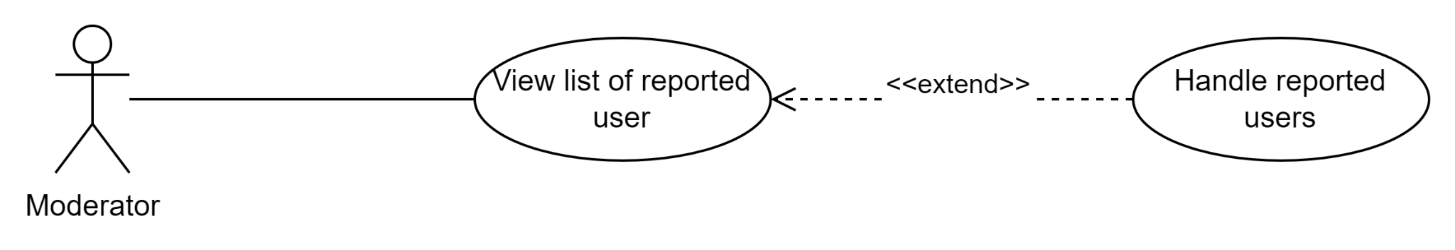

| **USE CASE-20 SPECIFICATION** | | | | | | | | | | | | |
| --- | --- | --- | --- | --- | --- | --- | --- | --- | --- | --- | --- | --- |
| **Use-case No.** | UC020 | | | | **Use-case Version** | | | | UC003 | | | |
| **Use-case Name** | View Reported User | | | | | | | | | | | |
| **Author** | Nguyen Tan Hung | | | | | | | | | | | |
| **Date** | 25/02/2024 | | | | **Priority** | | | | UC003 | | | |
| **Actor:**  *Moderator*  **Summary:**  *This use case describes the process of a moderator viewing reports about the reported user by a user*  **Goal:**  *As a moderator, I want to see the list of reported users on the application.*  **Triggers**  *The moderator clicks the “Reported User” to activate this function.*  **Preconditions**  *The user must have previously logged in with a moderator account on the system.*  **Post Conditions**  *Displays a list of reported users. The administrator can click a button to handle the reported user*  **Main Success Scenario:**   | ***Step*** | ***Actor Action*** | ***System Response*** | | --- | --- | --- | | *1* | *The Moderator clicks the “Reported User” button.* | *The system displays a list of reported users in the app on the website.*  *[Artist Id], [Artist Name], [Ban artist button]* |   **Alternative Scenario**  *N/A.*  **Exceptions:**   | ***Step*** | ***Actor Action*** | ***System Response*** | | --- | --- | --- | | *1* | *The Moderator removes the post/user that another moderator is deleting.* | *The system displays an error message.* |   **Relationships**  *View report.*  **Business Rules:**  *Only the moderator can handle the reported post.* | | | | | | | | | | | | |

## 

## Update package



| **USE CASE-21 SPECIFICATION** | | | | | | | | | | | | |
| --- | --- | --- | --- | --- | --- | --- | --- | --- | --- | --- | --- | --- |
| **Use-case No.** | UC021 | | | | **Use-case Version** | | | | UC003 | | | |
| **Use-case Name** | Update package | | | | | | | | | | | |
| **Author** | Nguyen Tan Hung | | | | | | | | | | | |
| **Date** | 25/02/2024 | | | | **Priority** | | | | UC003 | | | |
| **Actor:**  *Admin*  **Summary:**  *This use case describes how the admin can update the package in the application.*  **Goal:**  *As an admin, I want to update the premium package in the web application*  **Triggers**  *The admin clicks the “Update package” to activate this function.*  **Preconditions**  *The user must have previously logged in with an admin account on the system.*  **Post Conditions**  *Packages updated by the administrator will display and apply the new information.*  **Main Success Scenario:**   | ***Step*** | ***Actor Action*** | ***System Response*** | | --- | --- | --- | | *1* | *The admin clicks “Update package”* | *The system displays the current information of the package being clicked by the admin on the website.*   * *[Package Name]: have 200 characters for max length.* * *[Description]: no validation* * *[Price]: should be a positive numeric value.* * *[Amount artwork]: should be a positive integer.* | | *2* | *The admin changes the information of the package.* | *The system verifies the new information of the package being entered by the admin.* | | *3* | *The admin clicks submit the new information.* | *The system updates the new information to the database.* |   **Alternative Scenario**  *N/A.*  **Exceptions:**   | ***Step*** | ***Actor Action*** | ***System Response*** | | --- | --- | --- | | *1* | *The user inputs invalid information in the form.* | *The system displays the error and pretends the user saved the new information.* |   **Relationships**  *View premium package.*  **Business Rules:**   * *The new information in the package must be valid.* * *Only the admin can update the package.* | | | | | | | | | | | | |

## Create package



| **USE CASE-22 SPECIFICATION** | | | | | | | | | | | | |
| --- | --- | --- | --- | --- | --- | --- | --- | --- | --- | --- | --- | --- |
| **Use-case No.** | UC022 | | | | **Use-case Version** | | | | UC003 | | | |
| **Use-case Name** | Create package | | | | | | | | | | | |
| **Author** | Nguyen Tan Hung | | | | | | | | | | | |
| **Date** | 25/02/2024 | | | | **Priority** | | | | UC003 | | | |
| **Actor:**  *Admin*  **Summary:**  *This use case describes how the admin can create the package in the application.*  **Goal:**  *As an admin, I want to create a premium package in the web application.*  **Triggers**  *The admin clicks the “Create package” to activate this function.*  **Preconditions**  *The user must have previously logged in with an admin account on the system.*  **Post Conditions**  *Packages updated by the administrator will display and apply the new information.*  **Main Success Scenario:**   | ***Step*** | ***Actor Action*** | ***System Response*** | | --- | --- | --- | | *1* | *The admin clicks “Create package”* | *The system displays the form to fill in the ìnormation of the new package on the website.*   * *[Package Name]: have 200 characters for max length.* * *[Description]: no validation* * *[Price]: should be a positive numeric value.* * *[Amount artwork]: should be a positive integer.* | | *2* | *The admin enters the new information about the package.* | *The system verifies the new information of the package being entered by the admin.* | | *3* | *The admin clicks submit the new information.* | *The system updates the new information to the database.* |   **Alternative Scenario**  *N/A.*  **Exceptions:**   | ***Step*** | ***Actor Action*** | ***System Response*** | | --- | --- | --- | | *1* | *The user inputs invalid information in the form.* | *The system displays the error and pretends the user saved the new information.* |   **Relationships**  *View premium package.*  **Business Rules:**   * *The new information in the package must be valid.* * *Only the admin can update the package.* | | | | | | | | | | | | |

## Delete Package



| **USE CASE-23 SPECIFICATION** | | | | | | | | | | | | |
| --- | --- | --- | --- | --- | --- | --- | --- | --- | --- | --- | --- | --- |
| **Use-case No.** | UC023 | | | | **Use-case Version** | | | | UC003 | | | |
| **Use-case Name** | Delete package | | | | | | | | | | | |
| **Author** | Nguyen Tan Hung | | | | | | | | | | | |
| **Date** | 25/02/2024 | | | | **Priority** | | | | UC003 | | | |
| **Actor:**  *Admin*  **Summary:**  *This use case describes how the admin can delete the package in the application.*  **Goal:**  *As an admin, I want to delete the premium package in the web application*  **Triggers**  *The admin clicks the “Delete package” to activate this function.*  **Preconditions**   * *The user must have previously logged in with an admin account on the system.* * *The user must be on the View package page.*   **Post Conditions**  *Packages deleted by the administrator will not display on the application.*  **Main Success Scenario:**   | ***Step*** | ***Actor Action*** | ***System Response*** | | --- | --- | --- | | *1* | *The admin clicks “Update package”* | *The system asks the user to confirm the process to delete the package from the database.* | | *2* | *The admin clicks “Yes” to confirm.* | *The system deletes the package from the database and shows the successful notification.* |   **Alternative Scenario**  *N/A.*  **Exceptions:**   | ***Step*** | ***Actor Action*** | ***System Response*** | | --- | --- | --- | | *1* | *The user selects “No” when the system confirms.* | *The system still keeps the database of the package.* |   **Relationships**  *View premium package.*  **Business Rules:**  *Only the admin can update the package.* | | | | | | | | | | | | |

## View blogs

## 

| **USE CASE-6 SPECIFICATION** | | | | |
| --- | --- | --- | --- | --- |
| **Use-case No.** | UC006 | **Use-case Version** | | 1.0 |
| **Use-case Name** | View blogs | | | |
| **Author** | Dang Cong Hung | | | |
| **Date** | 25/02/2024 | **Priority** | Normal | |
| **Actor:**  *Creator, Customer, Guest, Moderator.*  **Summary:**  *This use case describes the process of creators or customers or guests or moderators viewing blogs on the blog page.*  **Goal:**  *The actor (Creator or Customer or Guest or Moderator) is able to view artworks on the blog page.*  **Triggers**  *The actor (Creator or Customer or Guest or Moderator) wants to view blogs.*  **Preconditions:**  *N/A*  **Post Conditions:**  *The systems successfully display the blogs on the blog page.*  **Main Success Scenario:**     | ***Step*** | ***Actor Action*** | ***System Response*** | | --- | --- | --- | | *1* | *1. On the homepage, the actor clicks on the “Blog” button.*  *[Alternative 1]* | *1. The system redirects to the blog page show all blogs. Each blog will display the the picture, the title, the description and a “More” button.* |   **Alternative Scenario:**  *1:*   | ***Step*** | ***Actor Action*** | ***System Response*** | | --- | --- | --- | | *1* | *1. The actor clicks on “View my blog” on the Creator Profile.* | *1. The system displays blogs belonging to that creator* |   **Exceptions:**  *N/A*  **Relationships:**  *View blog detail*  **Business Rules:**   * *Each of the blog must have a record in the storage and still be available.* * *All blog information must be clear and up-to-date.* | | | | |

## View blog detail

## 

| **USE CASE-7 SPECIFICATION** | | | | |
| --- | --- | --- | --- | --- |
| **Use-case No.** | UC007 | **Use-case Version** | | 1.0 |
| **Use-case Name** | View blog detail | | | |
| **Author** | Dang Cong Hung | | | |
| **Date** | 25/02/2024 | **Priority** | Normal | |
| **Actor:**  *Creator, Customer, Guest, Moderator.*  **Summary:**  *This feature allows the actor (Creator or Customer or Guest or Moderator) to view a blog in detail.*  **Goal:**  *The actor (Creator or Customer or Guest or Moderator) can view a blog in detail.*  **Triggers**  *The actor (Creator or Customer or Guest or Moderator) clicks on the “More” link in the blog.*  **Preconditions:**  *The actor must be on the homepage or on an artwork detail page.*  **Post Conditions:**  *The system successfully displays the details of an artwork, along with like, share, report, and add to cart buttons, as well as a comment field.*  **Main Success Scenario:**     | ***Step*** | ***Actor Action*** | ***System Response*** | | --- | --- | --- | | *1* | *1. After the actor clicks on the “More” option under the picture of the blog on the blog page.*  *[Alternative 1]* | *1. The system redirects to the artwork detail page. The page displays the artwork's detailed information such as:*   * *The creator’s name (a link).* * *Picture.* * *Description.* * *Title.*   *and shows like, share, report, buttons, and a comment field.*  *[Exception 1]* |   **Alternative Scenario:**  *1*   | ***Step*** | ***Actor Action*** | ***System Response*** | | --- | --- | --- | | *1* | *1. After the actor clicks on the “More” option under the picture creator blog pag.* | *1. The system redirects to the artwork detail page. The page displays the artwork's detailed information such as:*   * *The creator’s name (a link).* * *Picture.* * *Description.* * *Title.*   *and shows like, share, report, buttons, and a comment field.*  *[Exception 1]* |   **Exceptions:**     | ***No*** | ***Cause*** | ***System Response*** | | --- | --- | --- | | *1* | *- The system cannot find the artwork detail in the database* | *The system displays an error message: “Artwork Detail not found”.* |   **Relationships:**  *- Report blog*  *- View creator*  **Business Rules:**  *N/A* | | | | |

## Report blog

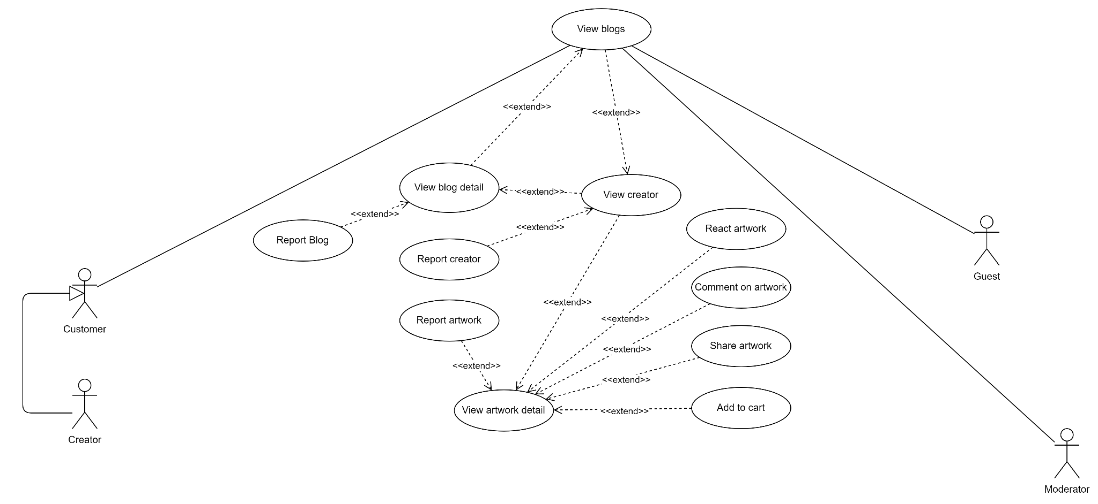

| **USE CASE-9 SPECIFICATION** | | | | | | | | | | | | |
| --- | --- | --- | --- | --- | --- | --- | --- | --- | --- | --- | --- | --- |
| **Use-case No.** | UC09 | | | | **Use-case Version** | | | | UC003 | | | |
| **Use-case Name** | Report blog | | | | | | | | | | | |
| **Author** | Dang Cong Hung | | | | | | | | | | | |
| **Date** | 25/02/2024 | | | | **Priority** | | | | UC003 | | | |
| **Actor:**  *Customer, Creator.*  **Summary:**  *This use case describes when a customer or creator reports the blog.*  **Goal:**  *As a customer or creator, I want to report the blog in the detail page of it*  **Triggers**  *The customer or creator clicks on the "Report" button in the artwork detail page.*  **Preconditions**  *The user must be on the detail page of the blog.*  **Post Conditions:**  *The information of the reported blog must be shown on the “View Reported Blog” page of the moderator role.*  **Main Success Scenario:**   | ***Step*** | ***Actor Action*** | ***System Response*** | | --- | --- | --- | | *1* | *Customer or Creator clicks on the report blog button.* | *The system display the form showing type of report message and and two buttons: “Report / Cancel”.* | | *2* | *Customer or Creator choose a type of report* |  | | *3* | *Customer or Creator clicks on report button.* | *The system redirects to the blog detail page.*  *[Exception 1]* |   **Alternative Scenario:**  *N/A.*  **Exceptions:**     | ***No*** | ***Cause*** | ***System Response*** | | --- | --- | --- | | *1* | *- The actor do not choose any type of report.* | *The system redirects to the form and displays an error.* |   **Relationships**  *View blog detail*  **Business Rules:**   * *The function must be carried out by the creator or customer.* * *The information on the reported blog must be saved in the database.* | | | | | | | | | | | | |

## 

## View list of orders



| **USE CASE-10 SPECIFICATION** | | | | |
| --- | --- | --- | --- | --- |
| **Use-case No.** | UC010 | **Use-case Version** | | <1.0> |
| **Use-case Name** | View list of orders | | | |
| **Author** | Dang Cong Hung | | | |
| **Date** | 25/02/2024 | **Priority** | High | |
| **Actor:**  *Creator, Admin,Customer*  **Summary:**  *This use case describes the process of the creator or the admin or the customer viewing the list of artworks on the artwork list page.*  **Goal:**  *The Creator or The Admin or The Customer is able to view the list of artworks on the artwork list page.*  **Triggers**  *The Creator or The Admin or The Customer clicks on the “Manage Artworks” option on the header.*  **Preconditions:**  *- The user must be authenticated and logged into the system as either a creator or an admin or a customer.*  **Post Conditions:**  *The system successfully displays a list of orders on the “Order List” page, providing processing and canceling buttons for admin.*  **Main Success Scenario:**     | ***Step*** | ***Actor Action*** | ***System Response*** | | --- | --- | --- | | *1* | *1. The actor clicks on the “Manage Artwork” option on the homepage.* | *The system displays the list of artworks, which includes the following details:*  *Price.*  *Title.*  *Description.*  *Category.*  *Additionally:*  *If the user is an admin, they can view all orders.*  *If the user is a customer or creator, they can view their own orders.* |   **Alternative Scenario:**  *N/A*  **Exceptions:**  *N/A*  **Relationships:**  *View order detail*  **Business Rules:**   * *If the user is an admin, they can view all orders.* * *If the user is a customer or creator, they can view their own orders.* | | | | |

## View order detail

## 

| **USE CASE-7 SPECIFICATION** | | | | |
| --- | --- | --- | --- | --- |
| **Use-case No.** | UC007 | **Use-case Version** | | 1.0 |
| **Use-case Name** | View artwork detail | | | |
| **Author** | Dang Cong Hung | | | |
| **Date** | 25/02/2024 | **Priority** | Normal | |
| **Actor:**  *Creator, Customer, Admin.*  **Summary:**  *This feature allows the actor (Creator or Customer or Admin) to view an order in detail.*  **Goal:**  *The actor (Creator or Customer or Admin) can view an order in detail.*  **Triggers**  *The actor (Creator or Customer or Admin) clicks on the detail button in the order.*  **Preconditions:**  *- The user must be authenticated and logged into the system as either a customer or a creator or an admin.*  *- The actor must be on the homepage or on an artwork detail page.*  **Post Conditions:**  *The system successfully displays the details of an artwork, along with like, share, report, and add to cart buttons, as well as a comment field.*  **Main Success Scenario:**     | ***Step*** | ***Actor Action*** | ***System Response*** | | --- | --- | --- | | *1* | *1. After the actor clicks on the “Detail” button in the corresponding blog.*  *[* | *1. The system redirects to the blog detail page and displays the information of ordered artwork or package. If the actor is a customer or a creator, the page displays the readonly user’s detailed information including:*   * *Name.* * *Phone* * *Email.* * *Order Date* * *Payment Date.* * *Payment Status*   *If the actor is ad admin, the systems will show more information including: Payment Intend ID*  *Session ID.*  *and a proccess, cancel buttons.*  *[Exception 1]* |   **Alternative Scenario:**  *N/A*  **Exceptions:**    *N/A*  **Relationships:**  *View list of orders*  **Business Rules:**   * *The creator or the customer can view readonly field.* * *The admin can process and cancel an order.* | | | | |

## 

## Place Order

## 

| **USE CASE-5 SPECIFICATION** | | | | |
| --- | --- | --- | --- | --- |
| **Use-case No.** | UC005 | **Use-case Version** | | 1.0 |
| **Use-case Name** | Place Order | | | |
| **Author** | Dang Cong Hung | | | |
| **Date** | 25/02/2024 | **Priority** | High | |
| **Actor:**  *Creator, Customer.*  **Summary:**  *This use case describes the process of creators or customers placing their own orders.*  **Goal:**  *Creators or customers are able to place their own orders.*  **Triggers**  *Creators or customers click on the “Place Order” button on the summary page.*  **Preconditions:**  *- The user must be authenticated and logged into the system as either a customer or a creator.*  *- The actor must be on the Summary Page.*  *- The actor must have items in the cart.*  **Post Conditions:**  *- Creators or customers successfully place their own orders.*  **Main Success Scenario:**     | ***Step*** | ***Actor Action*** | ***System Response*** | | --- | --- | --- | | *1* | *1. The actor clicks on the Place Order button.* | *1. The system redirects to Stripe Payment page.*  *[Exception 1]* |   **Alternative Scenario:**  *N/A*  **Exceptions:**     | ***No*** | ***Cause*** | ***System Response*** | | --- | --- | --- | | *1* | *1. The artwork is already bought.* | *1. The system redirects to the Summary page informs error under the place order button.* |   **Relationships:**  *Pay by Stripe*  **Business Rules:**  *- The actor cannot buy the artworks that have been already bought.* | | | | |

## View creator

## 

| **USE CASE-24 SPECIFICATION** | | | | |
| --- | --- | --- | --- | --- |
| **Use-case No.** | UC024 | **Use-case Version** | | <1.0> |
| **Use-case Name** | View Creator | | | |
| **Author** | Phạm Lê Quý Anh | | | |
| **Date** | 01/02/2024 | **Priority** | Normal | |
| **Actor:**  *Customer, Creator, Moderator, Guest*  **Summary:**  *This use case describes the process of actors, including Customers, Creators, Moderators, and Guests, viewing the artist's profile associated with a particular artwork on the platform.*  **Triggers**  *The actors wants to see the artist’s information.*  **Preconditions:**  *The actors must be logged into their account (appropriate authorization).*  *The actors must be in the artwork detail page or the blog detail page.*  **Post Conditions:**  *The creator’s profile is displayed successfully to the user.*  **Main Success Scenario:**   | **Step** | **Actor action** | **System response** | | --- | --- | --- | | *1* | *The customer click to the creator’s name on artwork detail page.*  *[Alternative 1]* | *The system displays the creator’s name, avatar, their own artworks, and buttons for reporting and viewing their blogs.* |   **Alternative Scenario:**  *1:*   | ***Step*** | ***Actor Action*** | ***System Response*** | | --- | --- | --- | | *1* | *The customer click to the creator’s name on blog detail page.* | *The system displays the creator’s name, avatar, their own artworks, and buttons for reporting and viewing their blogs.* |     **Exceptions:**  *N/A*  **Relationships:**  *View Creator Blog*  *Report creator*  **Business Rules:**  *N/A* | | | | |

## Edit artwork



| **USE CASE-25 SPECIFICATION** | | | | |
| --- | --- | --- | --- | --- |
| **Use-case No.** | UC025 | **Use-case Version** | | 1.0 |
| **Use-case Name** | Edit artwork | | | |
| **Author** | Phạm Lê Quý Anh | | | |
| **Date** | 01/02/2024 | **Priority** | Normal | |
| **Actor:**  *Creator*  **Summary:**  *This use case describes the process of a creator editing the detailed information of their particular artwork on this platform.*  **Triggers**  *The information of the artwork changes, and the creators want to edit it*  **Preconditions:**   1. *The actor logs into the system with the role “Creator”(appropriate authorization)* 2. *The actor has already uploaded artwork.* 3. *The actor must be in the Manage Artwork page.*   **Post Conditions:**  *- The artwork’s information is edited*  **Main Success Scenario:**   | **Step** | **Actor action** | **System response** | | --- | --- | --- | | *1* | *The actor clicks to the artwork they want to change detail.* | *System displays the artwork’s edit profile form.* | | *2* | *The actor edits artwork’s information* | *System changes the information of artwork* | | *3* | *The actor saves new information of the artwork* | *System save the new information* |   **Alternative Scenario:**  *N/A*  **Exceptions:**  *The platform cannot connect with the server/ core system (due to network malfunction/ technical issues), the system displays an error message.*  **Relationships:**  *The “View list of artworks” extends to the “Edit artworks*  **Business Rules:**  *N/A* | | | | |

## View cart

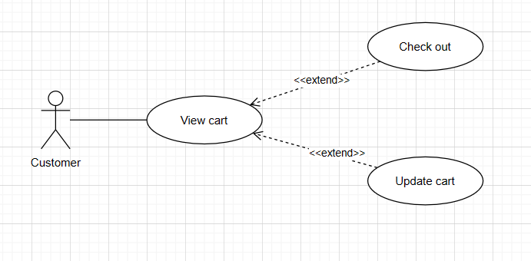

| **Use Case Specification** | | | |
| --- | --- | --- | --- |
| **Use Case No.:** | 27 | | |
| **Use Case Name:** | View cart | | |
| **Created By:** | Truong Nhat Hoang | | |
| **Date:** | 28/2/24 | **Priority:** | High |
| **Actors:** | Customer,Creator | | |
| **Summary:** | The Customer wants to view all the artworks they have added to the shopping cart. | | |
| **Trigger:** | The user clicks on a cart button. | | |
| **Preconditions:** | The user is logged into their account on the app as either a customer or a creator.. | | |
| **Post–conditions:** | Show all the available artworks in the shopping cart and allow users to remove cart. | | |
| **Main Success Scenario/Main Flow/Normal Flow/Main Path:**   | **Step.** | **Actor Action** | **System Response** | | --- | --- | --- | | 1 | Users click on the cart button. | The system redirects to view cart pages.  This page must show the basic information such as:   * name of artwork, price, numbers of artworks, total money; * the check out/update button;   Allow users to remove artworks from the cart. | | 2 | Users click on the update button.[Exception1] | The viewcart page must show the latest update. | | | | |
| **Alternative Flows:** | | | |
| **Exceptions:**   | **No.** | **Actor Action** | **System Response** | | --- | --- | --- | | 1 | Users receive an error when trying to click on the update button. | The system displays an error message and notifies “Please try again!!!” |   **Relationships:**   * *The base use case “View cart” has extension use cases : “Check out” and “Update cart”.* | | | |
| **Business Rules:** | 1. If the total money is less than 1, do not show total money. 2. The money is shown only 2 number after decimal point and have the dollar sign($) at the end(ex: 22.12$) 3. Check out buttons only available if there is at least 1 artwork in the cart. | | |

## 

## 

## Search artwork

| **Use Case Specification** | | | |
| --- | --- | --- | --- |
| **Use Case No.:** | 30 | | |
| **Use Case Name:** | Search artworks | | |
| **Created By:** | Truong Nhat Hoang | | |
| **Date:** | 28/2/24 | **Priority:** | Normal |
| **Actors:** | Customer, Guest,Moderator,Creator | | |
| **Summary:** | The actor (Customer or Guest or Moderator or Creator)wants to search for artworks. | | |
| **Trigger:** | The user clicks on a search button. | | |
| **Preconditions:** |  | | |
| **Post–conditions:** | After clicking on the search button, the user can see the short information of the artwork. | | |
| **Main Success Scenario/Main Flow/Normal Flow/Main Path:**   | **Step.** | **Actor Action** | **System Response** | | --- | --- | --- | | 1 | Users type in the searching box. | The system show the image, title of searched artworks. | | | | |
| **Alternative Flows:**  N/A | | | |
| **Exceptions:**  N/A  **Relationships:**  *- the base use case “Search artworks” has an extension use case “View artworks”.* | | | |
| **Business Rules:** | 1. The search box allows 1-255 characters. 2. The search box does not allow special characters. 3. Only show a maximum 5-6 artworks for recommended results. | | |

# Flow Chart

## Upload artwork

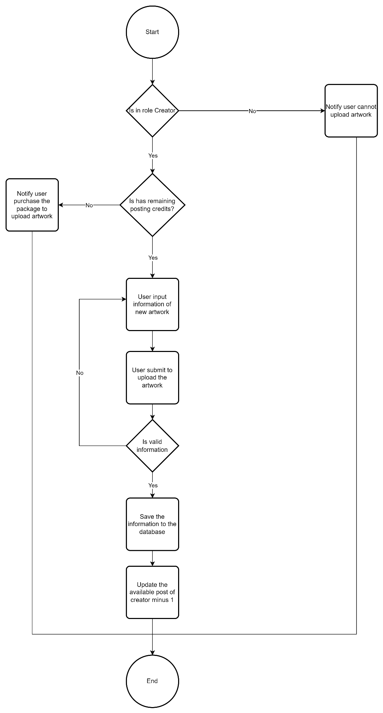

## View artwork detail

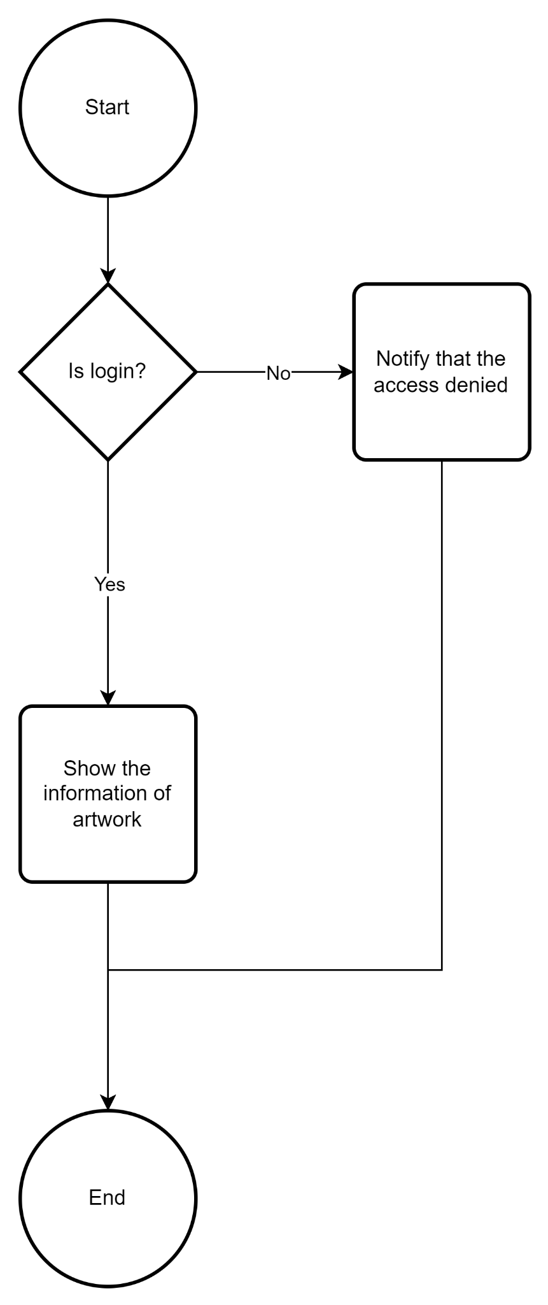

## Edit artwork

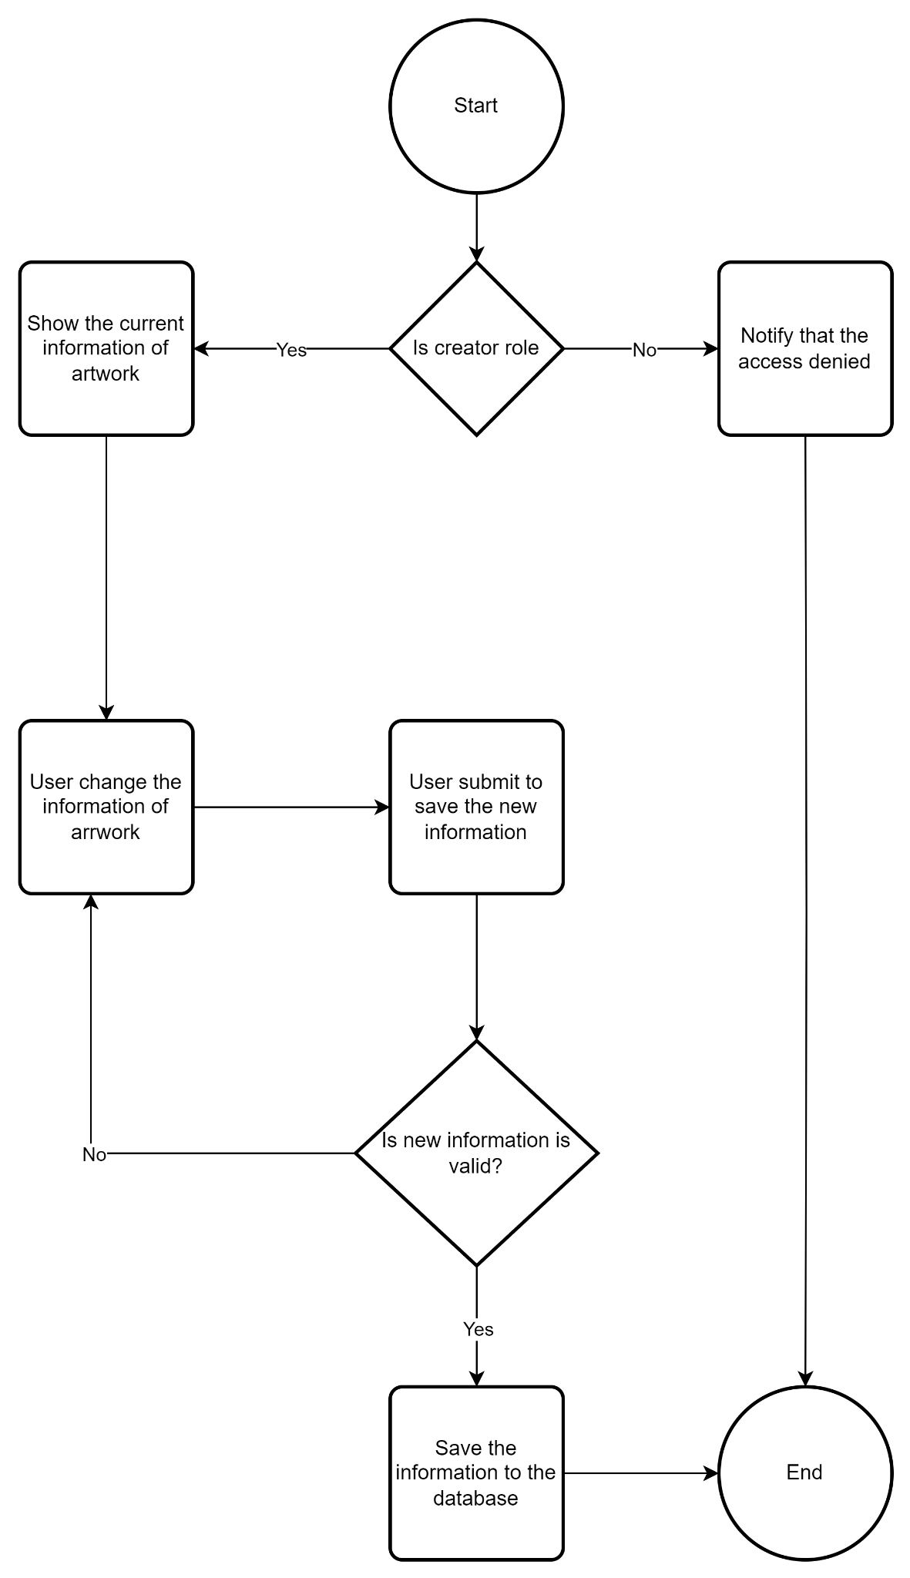

## Delete artwork

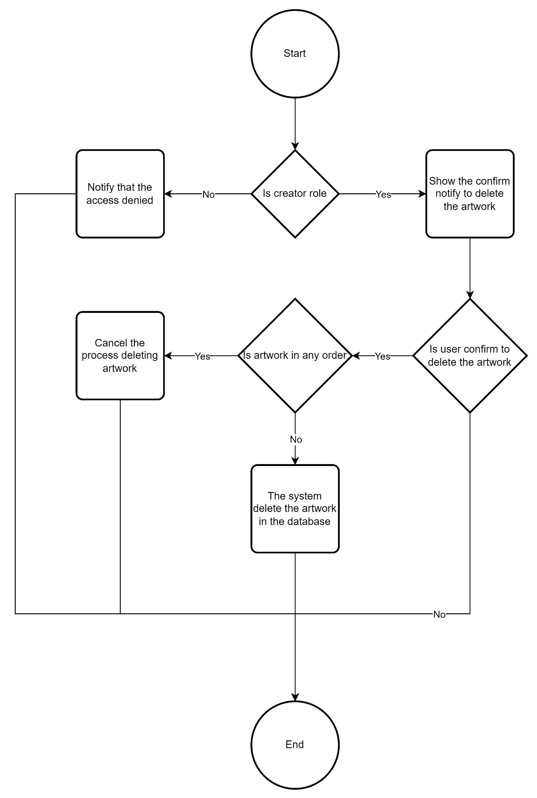

## Purchase package

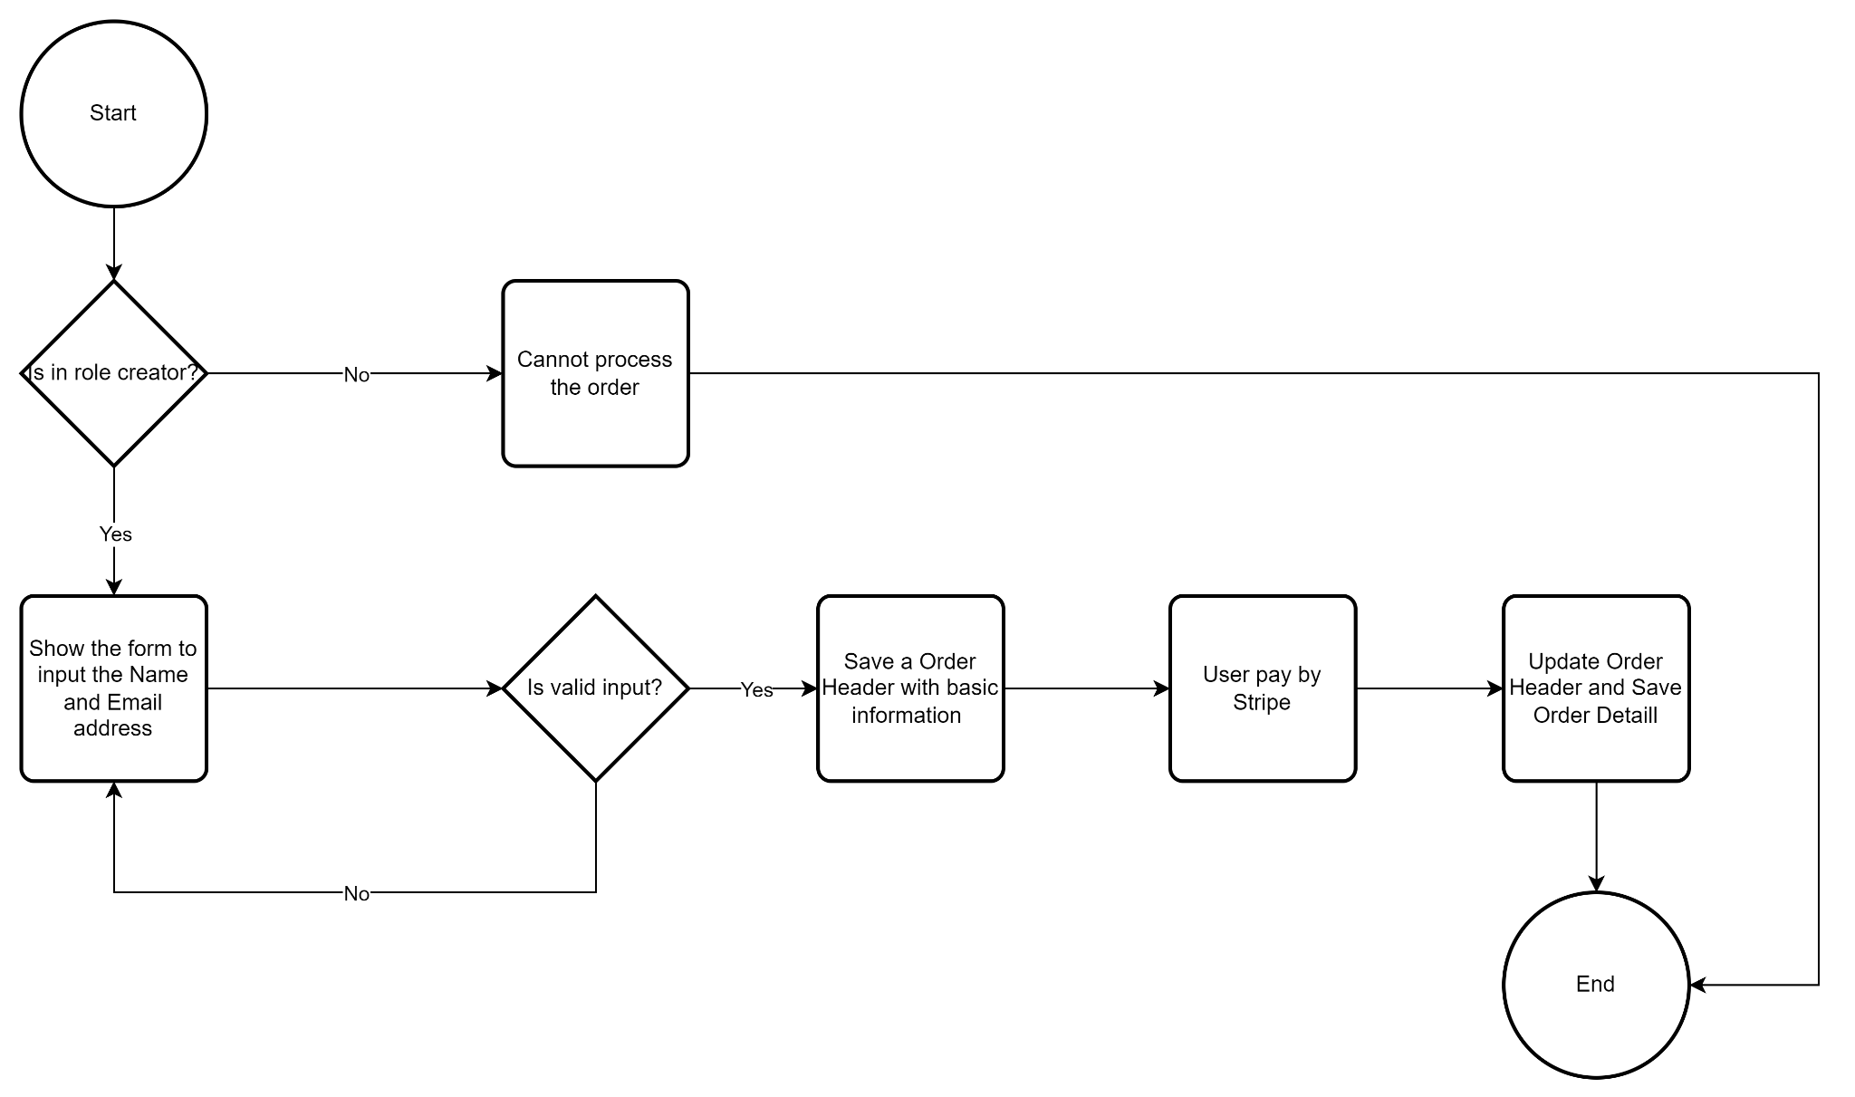

## Purchase artwork

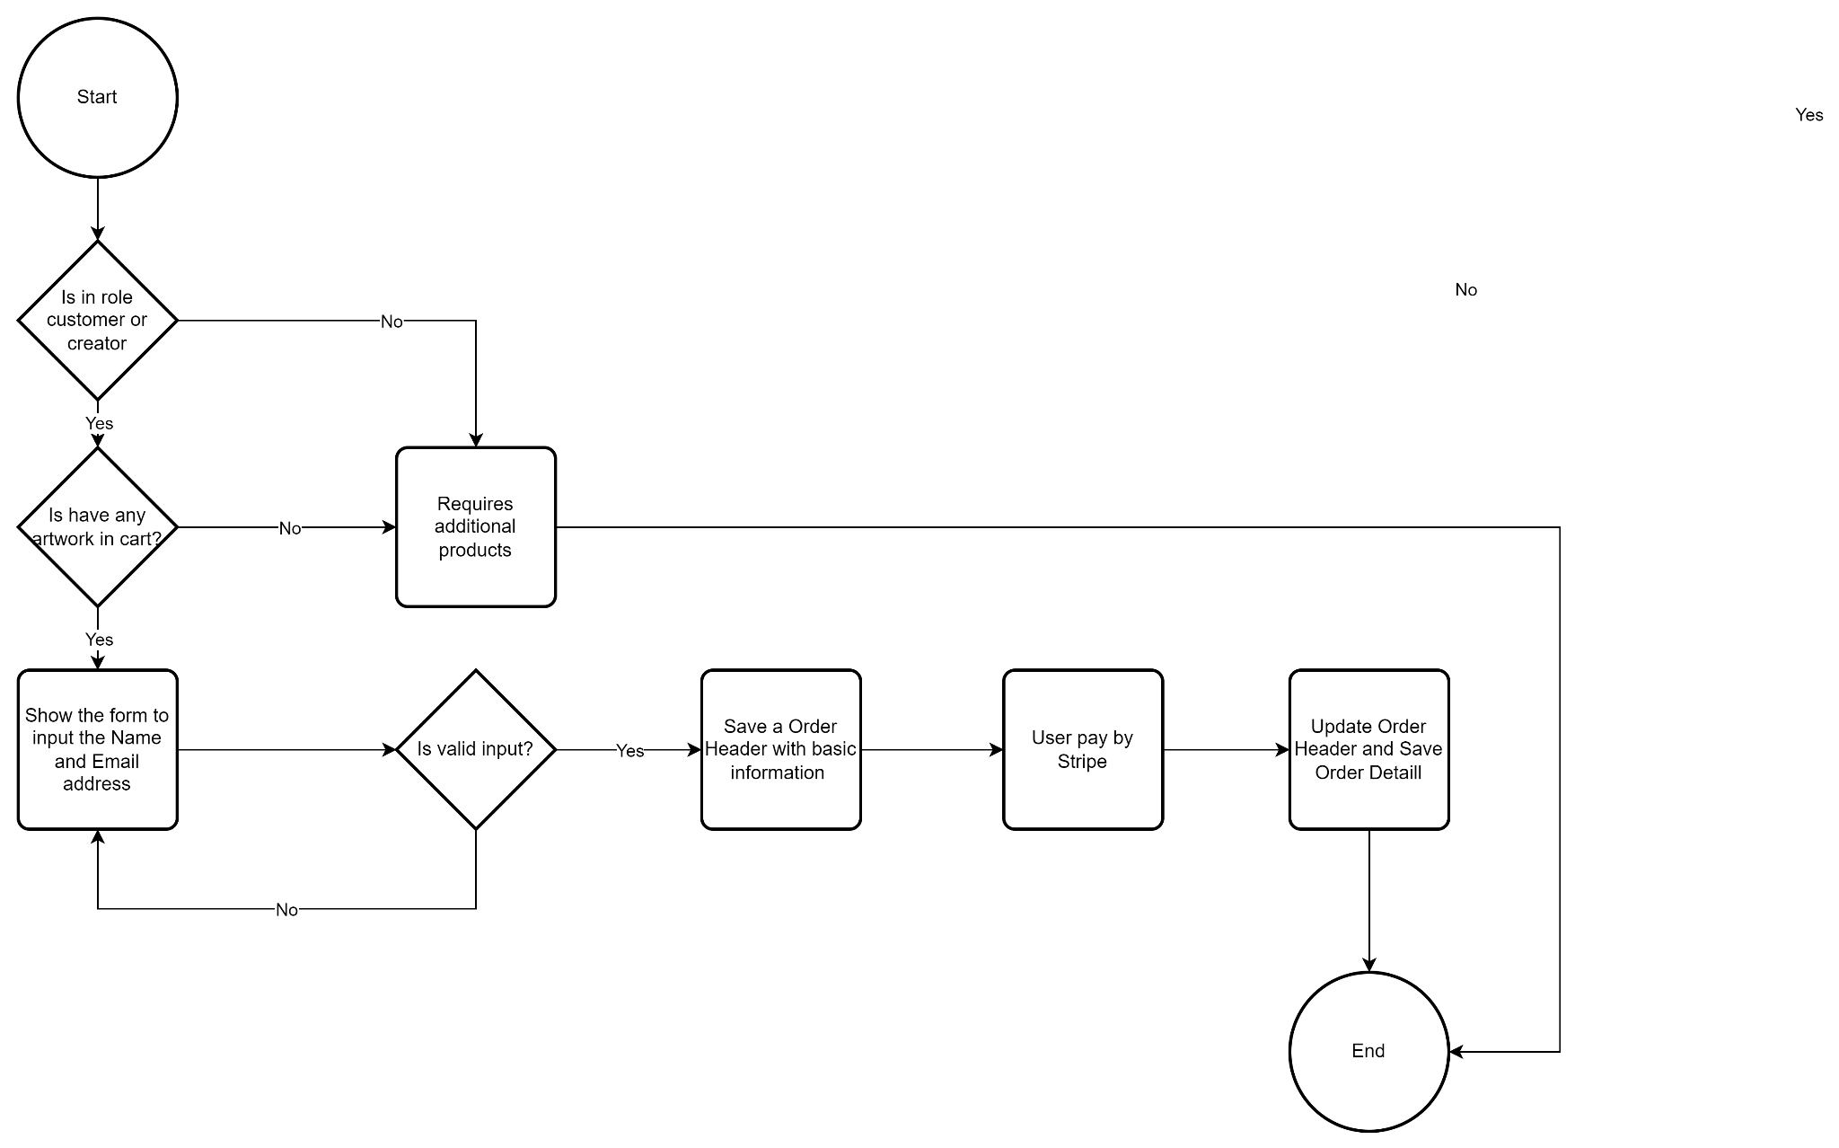

## Report artwork

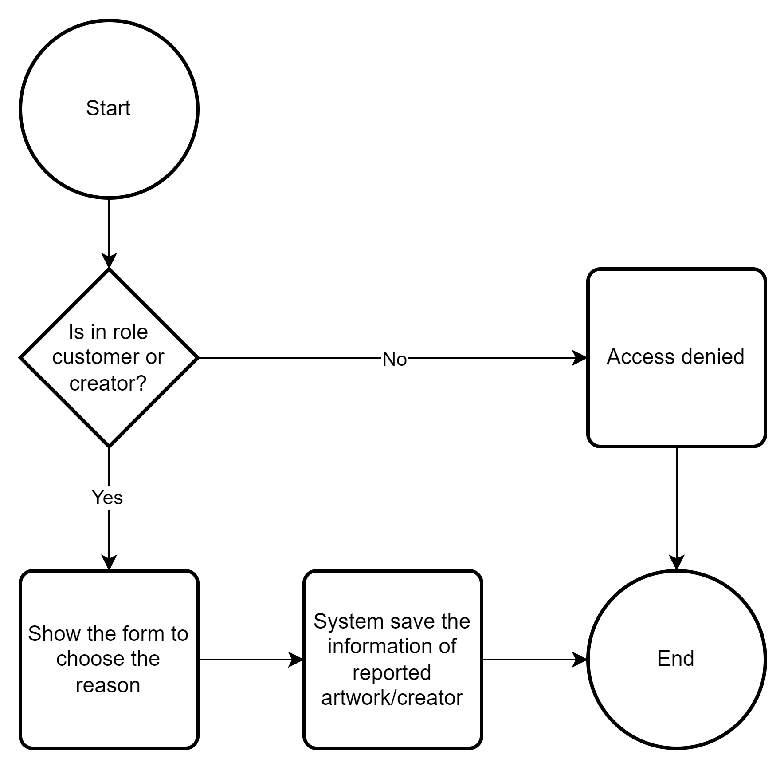

## Handle reported artwork

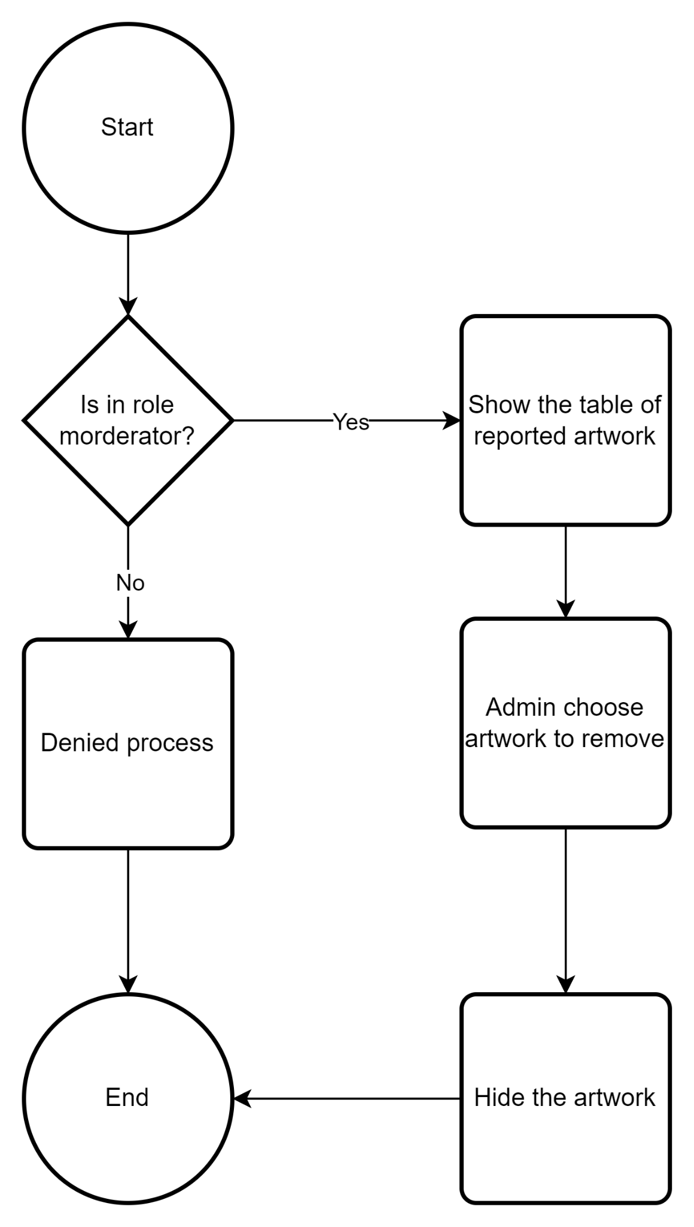

## Create package

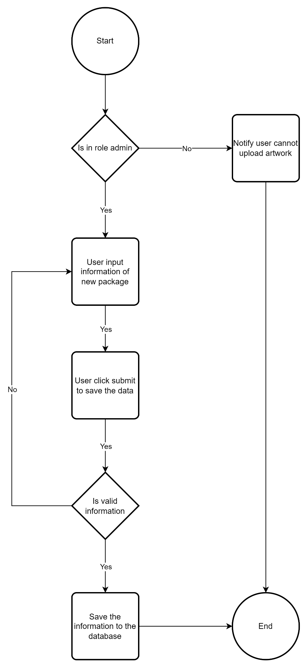

## View package

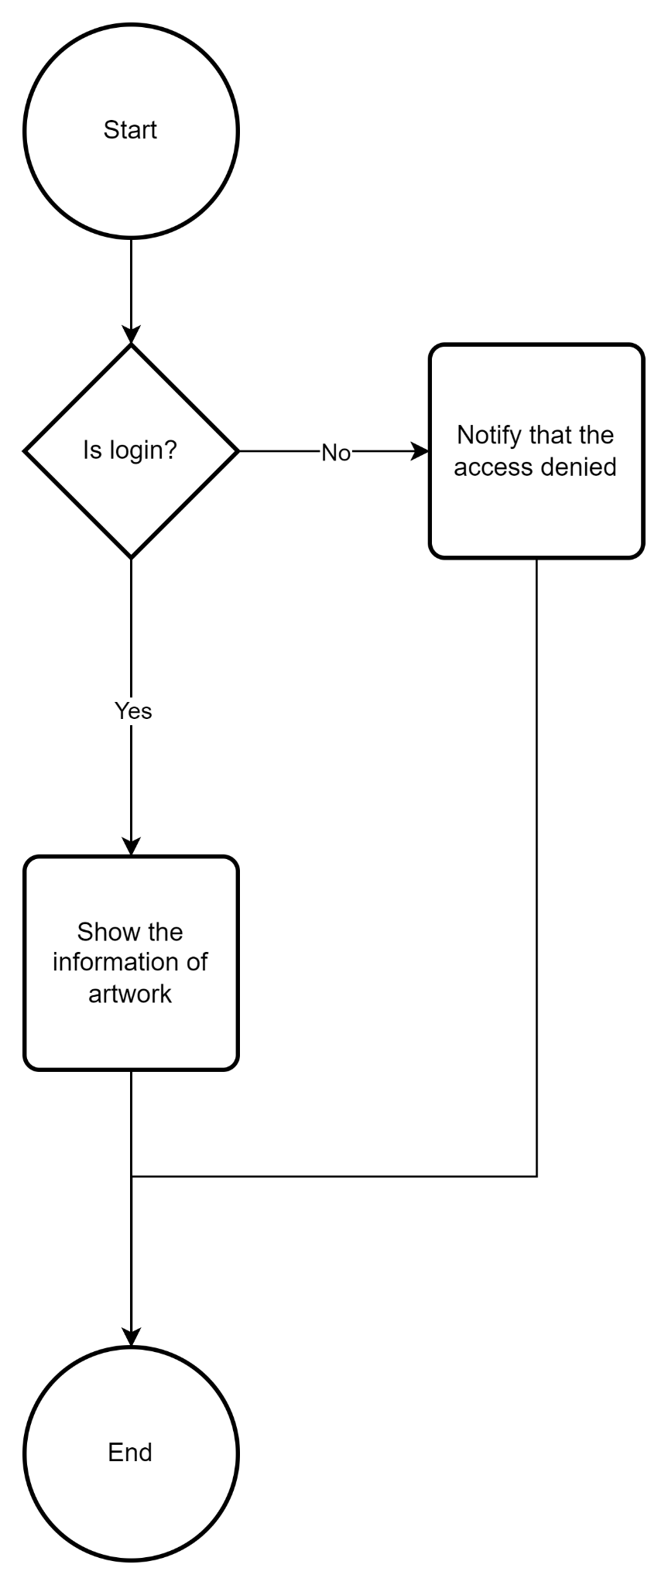

# NON-FUNCTIONAL Requirements

*[This section describes the non-functional requirements of the system. Some examples are listed as below]*

## Usability

### 4.1.1 User Interface Design

*Direct intuitive interface, easy to use for users with many different roles. Art projects are clearly displayed whether the user is logged in or not*

### 4.1.2 Navigation and Accessibility

*The platform shall provide easy and intuitive navigation for users to browse, search, and interact with artwork effectively. Navigation menus, search functionalities, and browsing options shall be prominently displayed and easily accessible from any page within the platform.*

### 4.1.3 Consistency and Familiarity

*The platform shall maintain consistency in layout, terminology, and user interaction patterns to ensure a familiar and predictable user experience.*

## Reliability

### 4.2.2 Navigation and Accessibility

*The artwork sharing platform shall demonstrate high reliability and stability, with minimal downtime and system failures. It shall be capable of handling concurrent user interactions and large volumes of data without compromising performance.*

### 4.2.2 Data Integrity

*It shall implement robust data validation and error-checking mechanisms to prevent data corruption or loss.*

## Performance

### 4.3.1 Response Time

*The platform shall exhibit fast response times for user interactions, with minimal latency in loading pages and displaying content.*

# 